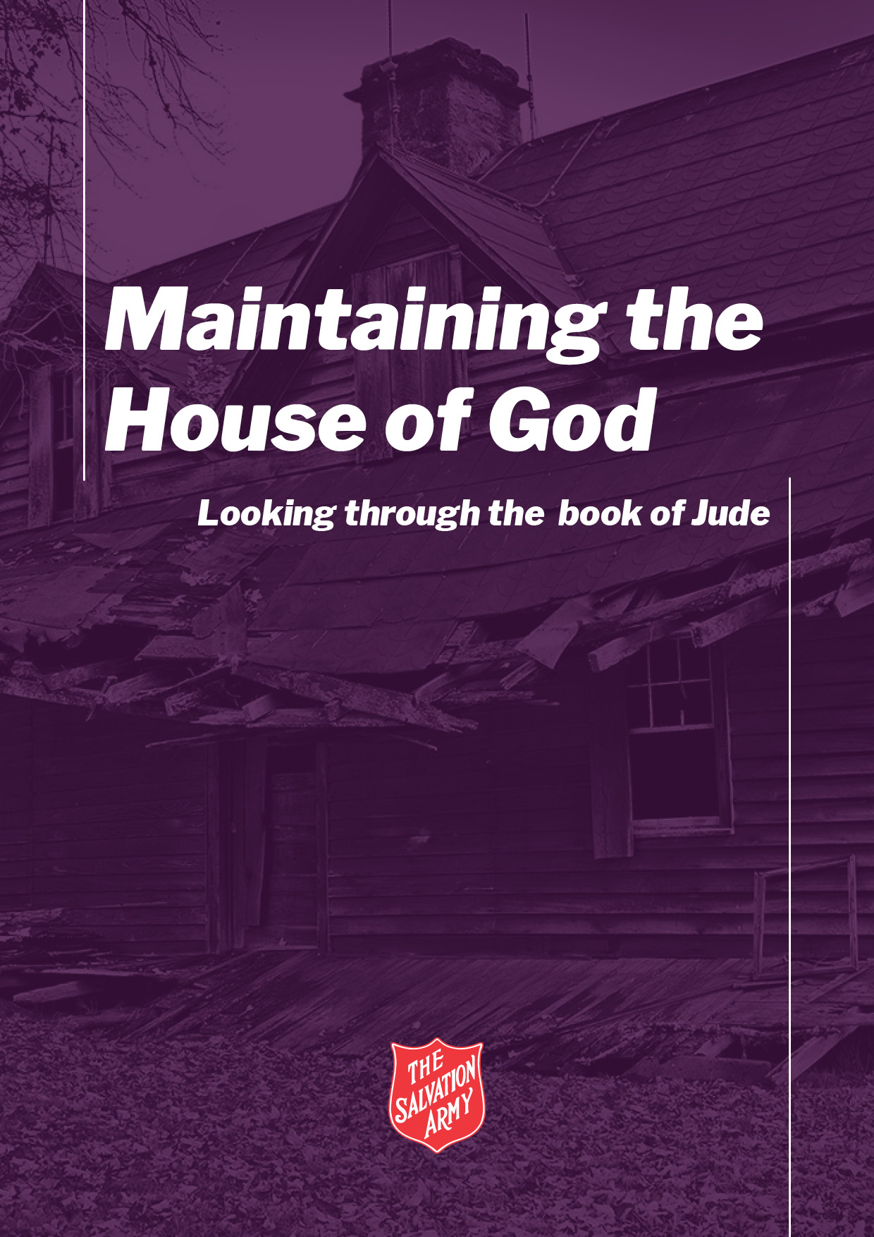

The Letter of Jude
Sermon Outline: Winning through Prayer

Topic: | Holding on to our faith
Main Point: | Jude outlines four ways to hold on to our faith
Intended Response: | Follow the pattern in Jude

Introduction
The letter of Jude serves as a window into the early church and holds a timely message for all of God’s people. Full of visual imagery and striking examples, Jude’s letter provides practical steps for staying full of faith.

- Window 1: Holding on to your faith
- The word ‘contend’ (Jd 1:3) means to hold onto / wrestle.
- Faith comprises holding onto the teachings of Jesus’ (our beliefs) and,
- Our commitment to it (obeying what Jesus taught us).

Point One: We are to hold on to to our faith.

- Window 2: Contending against
- We contend against false teaching.
- We contend bad attitudes and behaviours.
- We need to reflect on our attitudes and behaviours.

Point Two: We need to contend against false teachings and double standards.

- Window 3: How to hold on to our faith
- Hold on to and obey the teachings of Jesus.
- Pray, love others, wait patiently for Jesus’ return.

Point Three: If we hold on to Jesus’ teaching and obey them, if we pray, if we love, if wait – we will maintain the house of God.

- Window 4: God is holding on to us.
- God will guide us, keep us, and present us without fault.

Teaching Illustrations and props:
A fully designed PowerPoint slide deck is available for this sermon. You may also consider setting up window/picture frames as a visual reference to reinforce the message.
More resources for this sermon are available at www.SArmy.org.au
The Letter of Jude
Sermon Transcript: Winning through Prayer

Introduction: | This Slide  Good morning everyone, it’s good to be here with you all today.  It’s springtime! Flowers are in bloom. Bees are in the air. Birds are rebuilding their nests. Trees are sprouting new shoots. Fruit trees are in full production: apples, plums, apricots, peaches. The smell of freshly mowed lawns and petrol is in the air, cherry blossoms, lemons and limes also scenting the air. It’s a time of new growth, of life, of abundance.  But it’s also time for that dreaded weekend – the “spring-cleaning” weekend. Where everything in the house that is not nailed down gets cleaned, dusted, moved, rearranged, wiped, washed! Winter blankets are packed away. Jumpers are folded and put in the cupboard. Paths are swept, air conditioner filters are vacuumed (oh yes, we go all out) – the list goes on and on.  Does anyone here love spring cleaning? Oh yes, it’s wonderful, feel free to come round to my house next year and join in  In our house we have a fireplace, so springtime is a time for me to restack all the wood. Remove the kindling and logs from inside the house. Sweep and clean-out the fire tray and flue to get the chimney clean.  This Slide  And its time to clean the windows: to wash away the dusty rain marks, scrub away any bird poo, time to get rid of the cobwebs in the corners.  Spring-time serves as a good reminder to clean and maintain the house that we live in.  In 2 Cor 5:1, it says, “your body is the house of God”.  Now that’s an analogy for a spiritual truth – God dwells in us. The concept is that  God can live anywhere, but He has decided that His Spirit would live in you, in us – and together, we all make up the house of God.  Today, we are going to take a quick look at the Letter of Jude.  It serves as a window into the early church. A window which lets us peer in and see what’s going on and how it is relevant for us all here today.  Essentially, this is a spring-cleaning type of letter.  The church Jude is writing to are enjoying the blessing of living the Christian life. We learn they were a people of faith and fellowship.  But, we also learn that they need to maintain their faith and fellowship:  - False and misleading teachings have made their way into the church,  - They have poor behaviour and are telling others to live like them.  So Jude writes this letter, and in essence encourages the church to ‘spring clean’ the house of God.  So this morning, we are going to peer in through the window of the letter of Jude and learn a few lessons that are helpful for us all here today.
Transition | The first window we’re going to look through is verse 1-3…
A. Window 1 | And I’d like us to focus on the word contend… (read vs. 1-3)  This Slide  This Slide  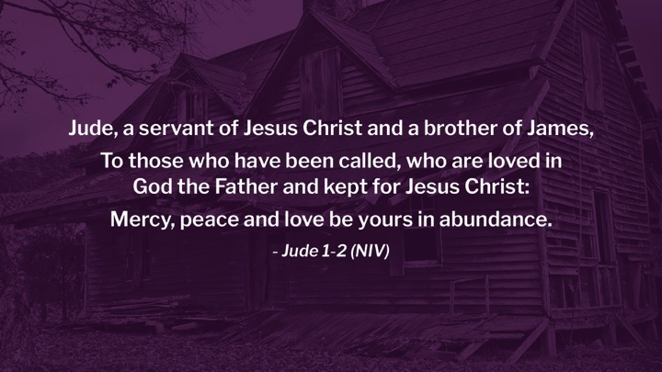  This Slide  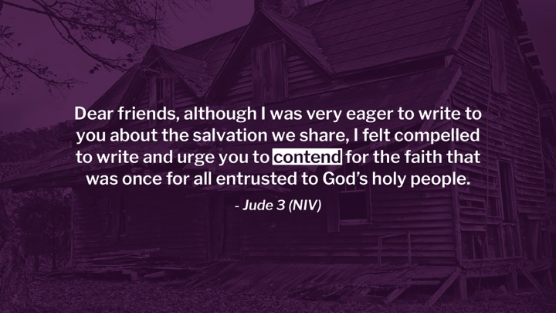  Now the word contend means: to wrestle for and to hold on to.  This Slide  Jude encourages the church to hold on to for their most holy faith – but what is that?  As you read Scripture, you’ll see that our most holy faith is  - The teachings of Jesus’ (our faith / beliefs) and  - Our commitment to it (obeying what Jesus taught us)  And the reasons for the encouragement is because we can let it slip, we can lose ground, we can be pulled over the line into the wrong attitudes and behaviours.  There’s an old saying “our enemy never sleeps” – we are in a spiritual battle at times. We need to hold on to our faith because life gets challenging.
Point 1. | So we are to hold on to our faith.
Transition | But as we look through the second window in Jude, we realize we also need to contend against …
B. Window 2 | And this is the second window in Jude we’ll look through today…  This Slide  When we first give our lives to Jesus, we are given a new start, a fresh beginning. God sends His Spirit into our soul and we become the House of God …  This Slide  A brand new start, made perfect in God’s eyes, renewed, a fresh beginning, a new house.  But as we’ll see in a moment if we do not hold on our beliefs – wrestle for our faith – our spiritual life can become a mess.  This Slide  In this letter, Jude writes a lot about people who have come into the church are contending against the teachings of Jesus.  Jude warns the church about these types of attitudes and traits (read vs.4-19)  These Slides  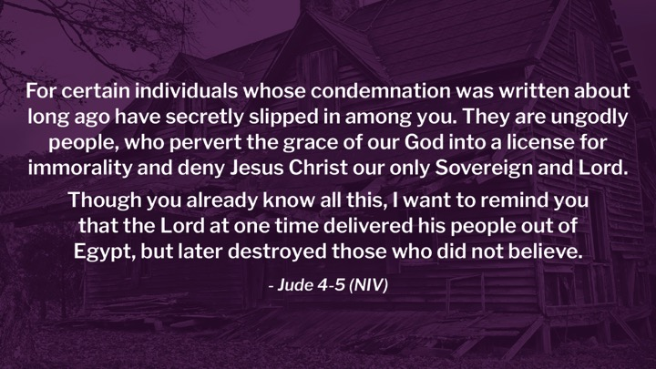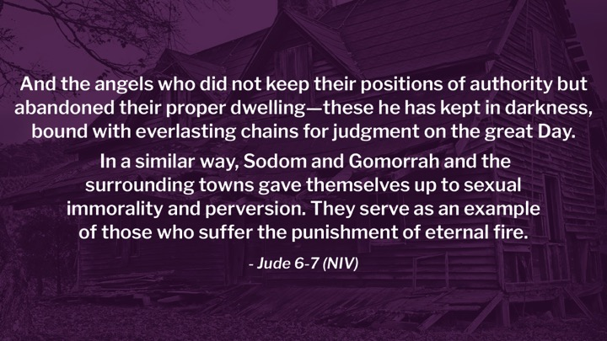  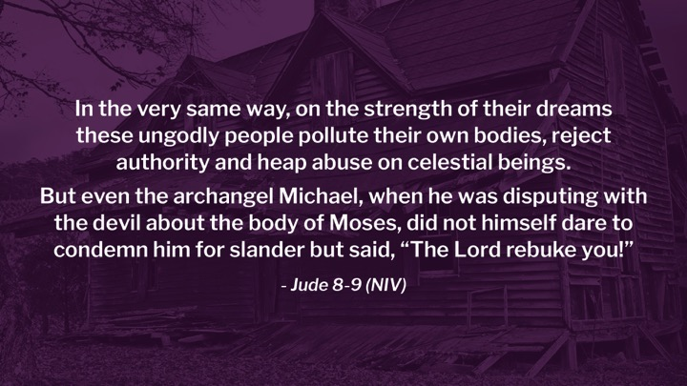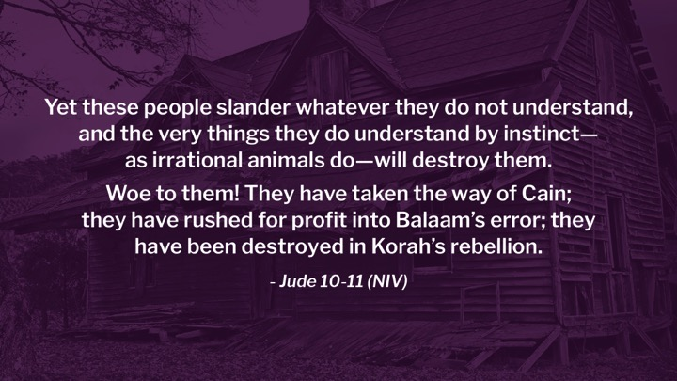  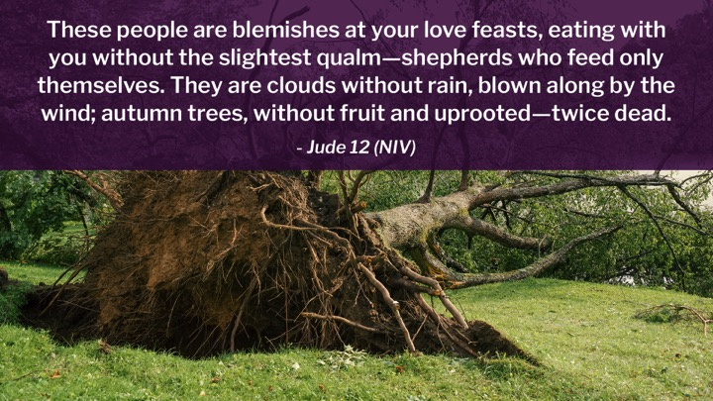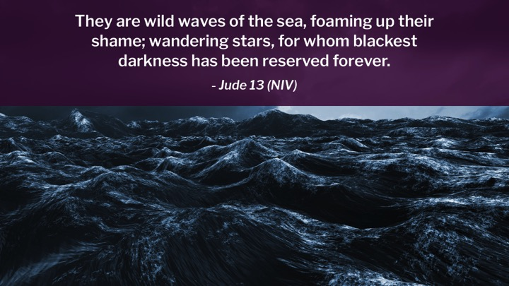  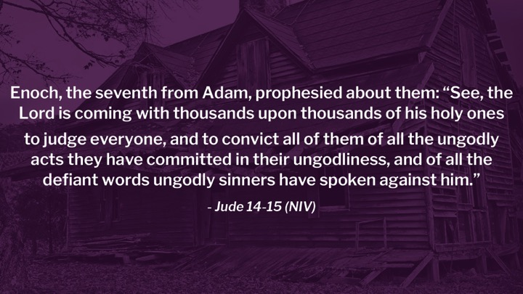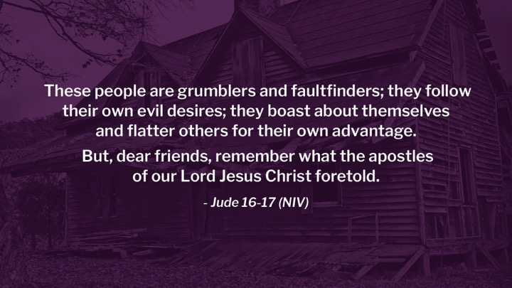  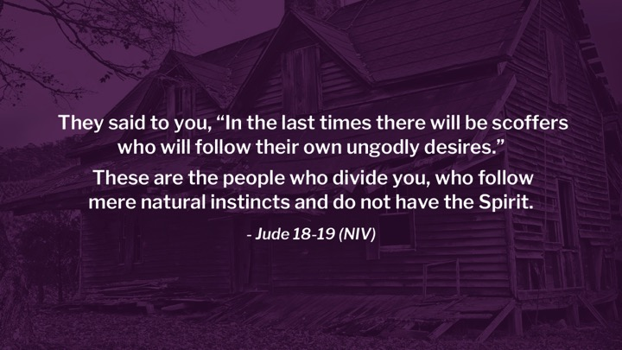  Well that’s a lovely list for a Sunday morning isn’t it Very uplifting - pretty full on.  So a quick recap, these people are  - Saying it’s okay to use grace as a reason to keep on sinning,  - They deny the authority of Jesus,  - They are greedy and rebellious,  - They grumble,  - Are faultfinders,  - Boastful and use flattering words.  We face the same type of challenges and attitudes and traits today:  - People at work or school or Uni who don’t believe in God and try and convince others God is not real.  - Politicians who are trying to push Jesus out of modern day conversation, restrict Christian freedom, bring in unfair policies.  - You might know people like this  Jude’s warning are as relevant today as they were then.  You may have heard a false teaching saying, it’s okay to sin because of God’s grace – no it isn’t. We have freedom from sin, not to sin (Rom 6:1-2).  Or you may have heard a false teaching saying, Jesus is not the only way to God – Yes HE is.  So the warning is clear– these type of teachings can shipwreck / damage our faith.  But it’s easy to look at others. But as much as the Bible is a window, its main purpose is to be a mirror. We read Scripture and reflect on our behaviour: I can be a fault finder, I can be selfish and greedy. Little attitudes can grow into big problems.  Can I ask, how are you doing? How’s your lifestyle – is it God honoring? How’s your theology – do you believe Jesus is the only way? How’s your generosity – are you sharing with others?  We need to contend against false teachings and our potential own double standards
Point 2. | We need to contend against false teachings and double standards
Transition | Let’s look through the third window…
C. Window 3 | This Slide  Jude gives us some tips on how we should contend (read vs. 20-21)  This Slide  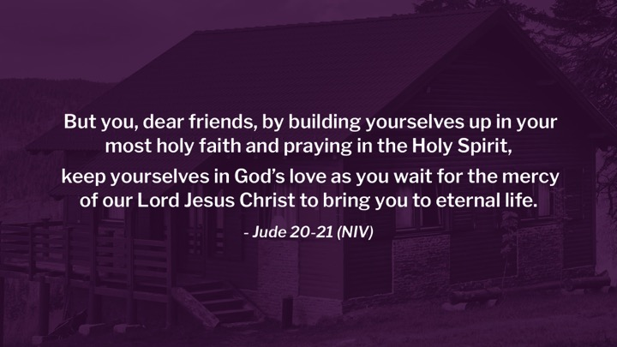  1. Build  Building imagery – here’s how you build a house – get the foundation right: Jesus’ teaching (believe) and our commitment to it (obey).  I encourage you to regularly read the gospels and get to know Jesus.  Jesus is window into the Father’s heart – we know God through Jesus.  2. Pray  The best type of prayer is the type you actually do.  You might like to write out your prayers, or go for a prayer walk, prayer in the car. The main thing is that you actually pray.  3. Keep  We don’t have time to unpack this saying, but basically, God is love and we demonstrate our love towards Him through our actions of love towards others.  A great Scripture that explains all this can be found in 1 Jn 4:16-2, I encourage you to make it part of your devotional reading this week.  4. Wait  Don’t lose sight of Jesus’ return. We are called to reveal the Kingdom of God now – to fight against injustice, help others, to practically demonstrate our faith.  But one day, Jesus will return and interrupt this world forevermore.  (read Matthew 25, John’s gospel, Revelation, Amos, Daniel, Joel, Acts)  John 14:3  In my Father's house has many mansions; if that were not so, would I have told you that I am going there to prepare a place for you? I go and prepare a place for you, I will come back and take you to be with me that you also may be where I am.  This Slide  When was the last time you paused and reflected on Jesus’ return?
Point 3: | If we hold onto Jesus’ teaching and obey them, if we pray, if we love, if wait – we will maintain the house of God.
Transition | And Jude saves the best window for last…
D. Window 4 | This Slide  God is contending / holding on to us – it’s not all about what we do…  This Slide  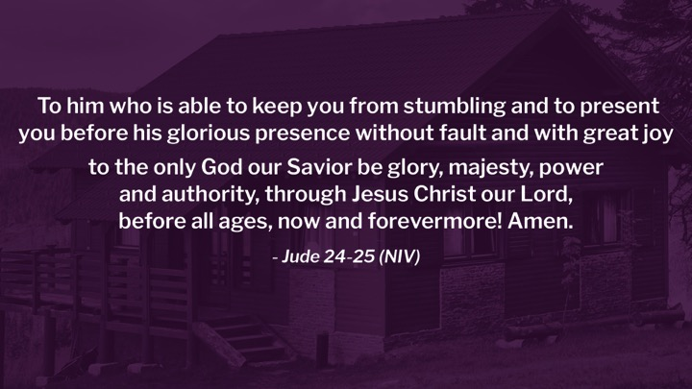  God keeps us from stumbling – like a Father helping a child as they learn to walk  God will ‘present’ us – the word means to stand. I’m reminded of Ephesians 6:13 that says,  Therefore put on the full armor of God, so that when the day of evil comes, you may be able to stand your ground, and after you have done everything, to stand.  Sometimes it’s hard to stand – but what’s so encouraging about God is that He will contend for us and help us stand.  And we will stand without fault – because of Jesus’ perfect sacrifice!
Point 4: | God is contending for us
Call to Action | This Slide  It’s spring-cleaning time – as we close today – can I ask you to reflect for a moment?  Is there anything you need to maintain - attitude, behaviour, lifestyle:  - How’s your prayer life, do you need to dust off the cobwebs from your Bible? When was the last time you sat down and thought about Jesus’ return?  - Do you think about how much God loves you  - God is contending for you  - God is holding onto you – He is joyous over you
Prayer | Let’s pray together,  Father, we thank you for all that you do. You guide us, you strengthen us, you work in us and through us. Fill us with the power of your Spirit here today so that we can reflect the love of Jesus in our communities. Help us to stand for truth, to contend for our faith. Help us to pray, to read Scripture, to stay close to you.  Help us share our faith with others in meaningful ways as we await your glorious return – Amen.
The Letter of Jude
Scriptures: Winning through Prayer

Jude 1:1-25 (NIV)

¹ Jude, a servant of Jesus Christ and a brother of James,
To those who have been called, who are loved in God the Father and kept for Jesus Christ:
² Mercy, peace and love be yours in abundance.
³ Dear friends, although I was very eager to write to you about the salvation we share, I felt compelled to write and urge you to contend for the faith that was once for all entrusted to God’s holy people.
⁴ For certain individuals whose condemnation was written about long ago have secretly slipped in among you. They are ungodly people, who pervert the grace of our God into a license for immorality and deny Jesus Christ our only Sovereign and Lord.
⁵ Though you already know all this, I want to remind you that the Lord at one time delivered his people out of Egypt, but later destroyed those who did not believe.
⁶ And the angels who did not keep their positions of authority but abandoned their proper dwelling—these he has kept in darkness, bound with everlasting chains for judgment on the great Day.
⁷ In a similar way, Sodom and Gomorrah and the surrounding towns gave themselves up to sexual immorality and perversion. They serve as an example of those who suffer the punishment of eternal fire.
⁸ In the very same way, on the strength of their dreams these ungodly people pollute their own bodies, reject authority and heap abuse on celestial beings.
⁹ But even the archangel Michael, when he was disputing with the devil about the body of Moses, did not himself dare to condemn him for slander but said, “The Lord rebuke you!”
¹⁰ Yet these people slander whatever they do not understand, and the very things they do understand by instinct—as irrational animals do—will destroy them.
¹¹ Woe to them! They have taken the way of Cain; they have rushed for profit into Balaam’s error; they have been destroyed in Korah’s rebellion.
¹² These people are blemishes at your love feasts, eating with you without the slightest qualm—shepherds who feed only themselves. They are clouds without rain, blown along by the wind; autumn trees, without fruit and uprooted—twice dead.
¹³ They are wild waves of the sea, foaming up their shame; wandering stars, for whom blackest darkness has been reserved forever.
¹⁴ Enoch, the seventh from Adam, prophesied about them: “See, the Lord is coming with thousands upon thousands of his holy ones
¹⁵ to judge everyone, and to convict all of them of all the ungodly acts they have committed in their ungodliness, and of all the defiant words ungodly sinners have spoken against him.”
¹⁶ These people are grumblers and faultfinders; they follow their own evil desires; they boast about themselves and flatter others for their own advantage.
¹⁷ But, dear friends, remember what the apostles of our Lord Jesus Christ foretold.
¹⁸ They said to you, “In the last times there will be scoffers who will follow their own ungodly desires.”
¹⁹ These are the people who divide you, who follow mere natural instincts and do not have the Spirit.
²⁰ But you, dear friends, by building yourselves up in your most holy faith and praying in the Holy Spirit,

²¹ keep yourselves in God’s love as you wait for the mercy of our Lord Jesus Christ to bring you to eternal life.
²² Be merciful to those who doubt;
²³ save others by snatching them from the fire; to others show mercy, mixed with fear—hating even the clothing stained by corrupted flesh.
²⁴ To him who is able to keep you from stumbling and to present you before his glorious presence without fault and with great joy
²⁵ to the only God our Saviour be glory, majesty, power and authority, through Jesus Christ our Lord, before all ages, now and forevermore! Amen.

2 Cor 5:1
For we know that if the earthly tent we live in is destroyed, we have a building from God, an eternal house in heaven, not built by human hands.

Rom 6:1-2
What shall we say, then? Shall we go on sinning so that grace may increase? By no means!

1 Jn 4:16-21
We have come to know and have believed the love which God has for us. God is love, and the one who abides in love abides in God, and God abides in him. By this, love is perfected with us, so that we may have confidence in the day of judgment; because as He is, so also are we in this world. There is no fear in love; but perfect love casts out fear, because fear involves punishment, and the one who fears is not perfected in love. We love, because He first loved us. If someone says, “I love God,” and hates his brother, he is a liar; for the one who does not love his brother whom he has seen, cannot love God whom he has not seen. And this commandment we have from Him, that the one who loves God should love his brother also.

John 14:3
“If I go and prepare a place for you, I will come again and receive you to Myself, that where I am, there you may be also.

Eph 6:13
Therefore put on the full armor of God, so that when the day of evil comes, you may be able to stand your ground, and after you have done everything, to stand.

Heb 12:2
Fixing our eyes on Jesus, the pioneer and perfecter of faith. For the joy set before him he endured the cross, scorning its shame, and sat down at the right hand of the throne of God.

Further Study
2 Peter 2, James

