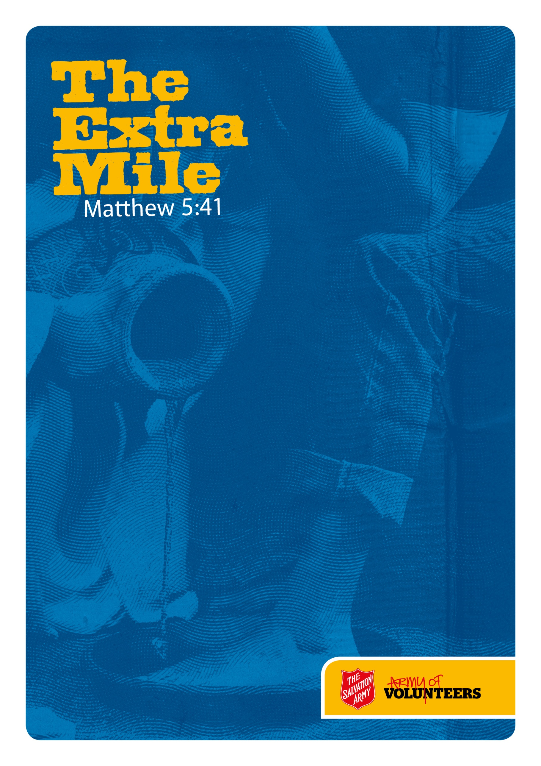


Sermon: Volunteer Appreciation Week
Sermon Outline: The Extra Mile

Big Idea: Appreciating Volunteers

Main Point: The Kingdom of God expands through the active service of volunteers

Intended Response: Let’s volunteer out time, gifts, and talents to show God’s love
to the world around us.

Key Verse: “If anyone forces you to go one mile, go with them two miles” (Matt 5:41)

Preface: Matthew 5:41
- In the times of Jesus, the Romans were the occupying military force. At random, they could force Jewish people to carry goods for them for up to one mile.
- Jesus flips the concept of being forced to do something into an opportunity to serve God.
- Volunteering allows us an opportunity to serve God and live out what Jesus taught.

Outline
- Jesus values volunteers
- Mark 10: 43-45 “… whoever wants to become great among you must be your servant…For even the Son of Man did not come to be served, but to serve”.
- Matthew 23:11-2 “The greatest among you will be your servant. For those who exalt themselves will be humbled, and those who humble themselves will be exalted.”
- Mark 9:35 “Anyone who wants to be first must be the very last, and the servant of all.”

Point One: Serving is the heartbeat of God’s kingdom

- Jesus volunteered himself
- The most compelling act of volunteerism is by Jesus himself.
- John 10:18 “No one takes it from me, but I lay it down of my own accord. I have authority to lay it down and authority to take it up again.”
- Luke 22:42 "Father, if you are willing, take this cup from me; yet not my will, but yours be done."

Point Two: Christ’s life demonstrates what the power of volunteerism can result in: the expansion of God’s kingdom

- Jesus encourages all to volunteer
- Serving God in all situations is a heart attitude (Eph 6:7, Col 3:23)
- Everyone has a gift they can use to help build the Church (Rom 12:6-8)

Point Three: We can turn around every opportunity to serve God – Go the extra Mile

Supporting the Sermon
Consider using the following to help communicate your message:
- Gather and share testimonies of people in your Corps who have been impacted by the gift of volunteers in their life e.g. soup kitchens, discipleship program teacher …
- Print out a Certificate of Appreciation and recognise a person in the Corps for their ongoing and consistent acts of service.

