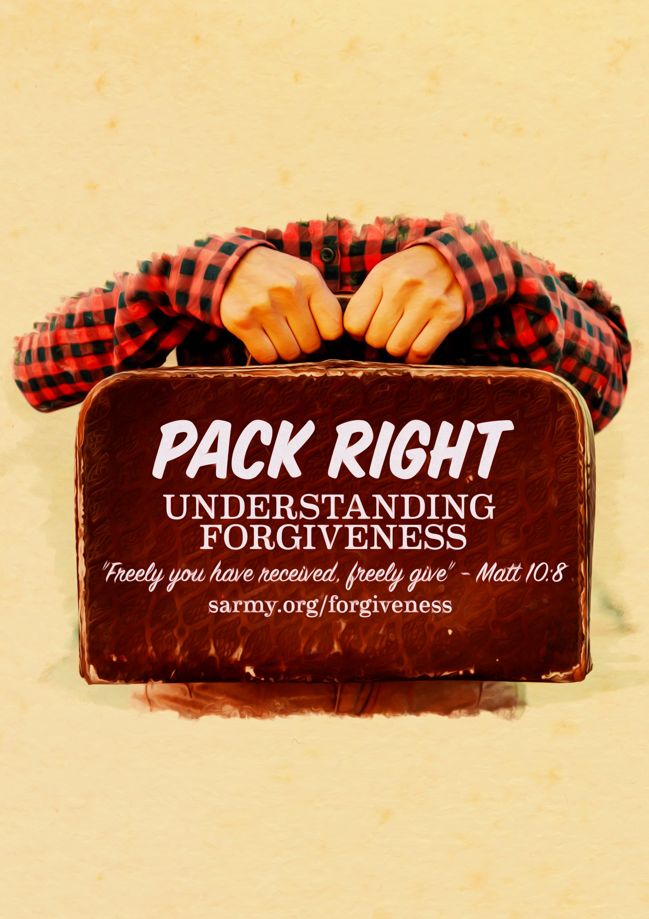



Sermon: Pack Right
Sermon Outline

Topic: | Forgiveness
Main Point: | We need to extend forgiveness towards others
Intended Response: | Practice forgiving others
Key Verse: | Matthew 10:8 “Freely you have received, freely give”

Outline

- Introduction
- The importance of Forgiveness
- Unforgiveness restricts genuine kindness

Point: We are instructed to forgive other

- Relevance
- Illustration: Airport security
- Media Clip: 1 min 15 secs

Point: There are certain attitudes that we just cannot carry with us on the Christian journey ahead.

- How to forgive
- Understand the importance of forgiving others
- Pray to God about the situation
- Acknowledge the pain and hurt
- Call on God’s grace and strength
- Know that Jesus’ sacrifice is enough

Point Three: We need to unpack any unforgiveness in our hearts

Teaching Illustration:
- Suggested props: suitcase, back pack, travel bag
- A Media clip available for this sermon
- PowerPoints available for this sermon

