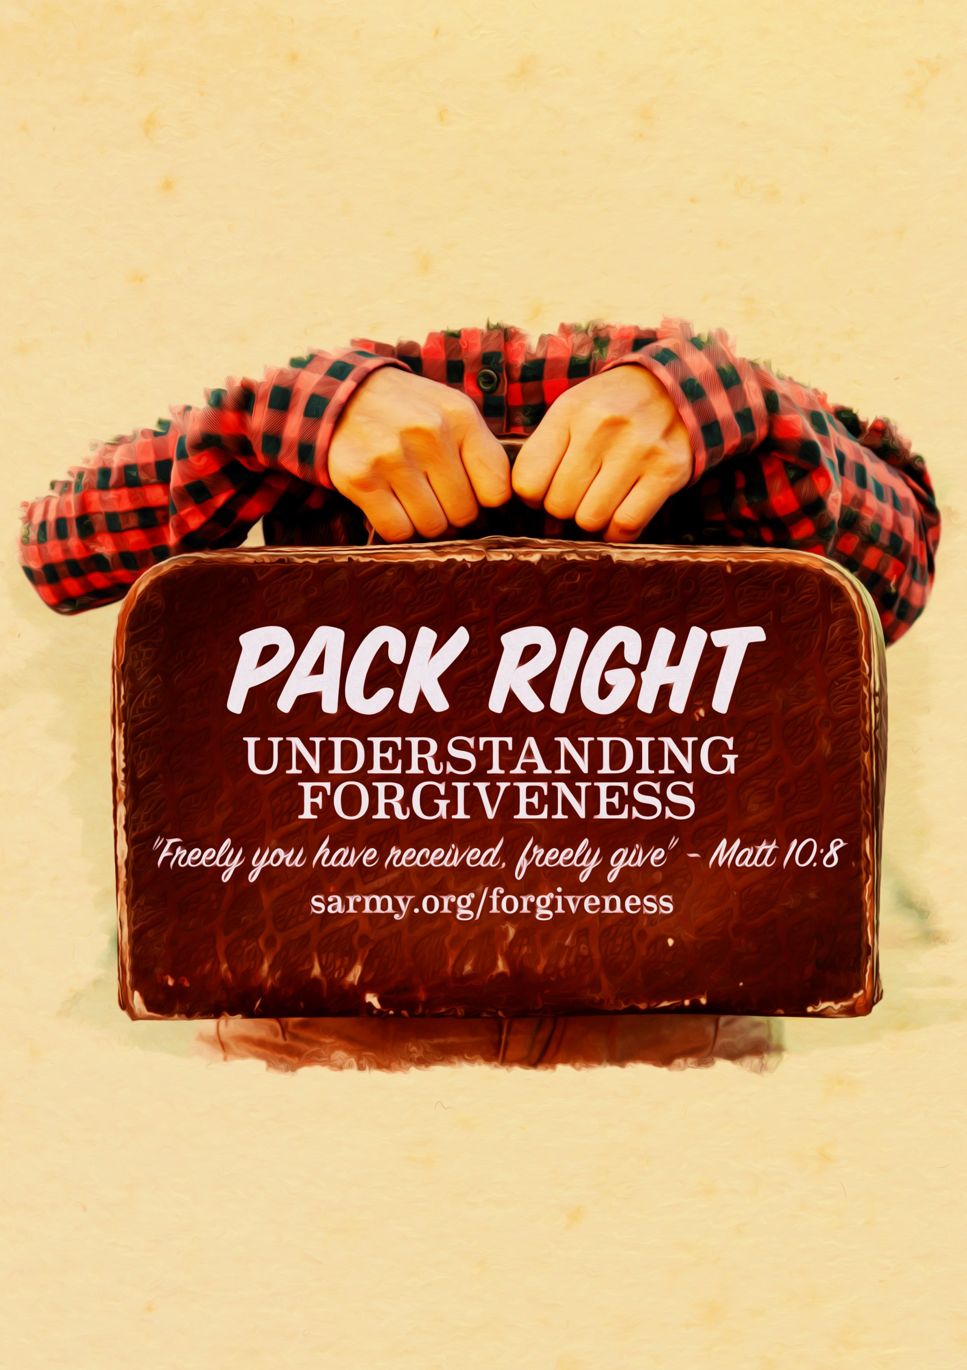



Sermon: Pack Right
Sermon Outline

Topic: | Forgiveness
Main Point: | We need to extend forgiveness towards others
Intended Response: | Practice forgiving others
Key Verse: | Matthew 10:8 “Freely you have received, freely give”

Outline

- Introduction
- The importance of Forgiveness
- Unforgiveness restricts genuine kindness

Point: We are instructed to forgive other

- Relevance
- Illustration: Airport security
- Media Clip: 1 min 15 secs

Point: There are certain attitudes that we just cannot carry with us on the Christian journey ahead.

- How to forgive
- Understand the importance of forgiving others
- Pray to God about the situation
- Acknowledge the pain and hurt
- Call on God’s grace and strength
- Know that Jesus’ sacrifice is enough

Point Three: We need to unpack any unforgiveness in our hearts

Teaching Illustration:
- Suggested props: suitcase, back pack, travel bag
- A Media clip available for this sermon
- PowerPoints available for this sermon
Sermon: Pack Right
Sermon Transcript

Introduction: | Welcome all to our Sunday service,  Today, we are going look at the topic of learning how to forgive others.  I’m sure we can all recall unpleasant experiencing in our lives caused by another person that left us feeling taken advantage of, perhaps bullied, or treated unfairly. Experiences like these can cause emotions of bitterness, anger, fear, or injustice within us.  Forgiveness is the conscious act of letting go of offence, bitterness, or hatred these experiences may cause us to feel towards another person.  Jesus placed huge importance on forgiving others all the way through His teachings:  - He taught that forgiving others should be a key element in our prayer lives.  - The Lord’s prayer states…“forgive us our sins as we forgive those who have sinned against us” (Matt 6:9-13).  - In Matthew 18:21, He spoke in illustrative terms to Peter about forgiving someone up to 490 times in a single day. In doing so, he was simply trying to highlight that there is to be no place in our heart that harbours unforgiveness.  - Overtly, Jesus demonstrated forgiveness on the cross, “Father, forgive them, for they know not what they do” (Lk 23:34)  By forgiving others, not only are we embracing the teachings of Christ, but we also demonstrate the love of Jesus towards others. Jesus said, “and this is how people will know you are my disciples, if you love one another” (Jn 13:35).  Unforgiveness on the other hand, is as the act of holding onto an offence or a sour attitude against another person. Sometimes this is referred to as ‘baggage’, that is, past issues we carry around with us that still feel as if they just happened yesterday.  Unforgiveness, or baggage as it were, restricts our ability to express love and genuine kindness towards others. In doing so, we subtly cut people off from the grace of God that is meant to be flowing through our lives.  For example, if we carry unforgiveness in our heart, we may experience:  - Constant negative thoughts against a particular person,  - We may find ourselves wishing them harm,  - We may cut people out of our lives and no longer see them,  - Unforgiveness can end friendships, prevent families from seeing each other,  - Someone once said, “unforgiveness is like eating rat poison and waiting for the rat to die”; it actually does more harm to the person who doesn’t forgive,  - Ultimately, unforgiveness can cause our hearts to grow cold before God and not embrace His teachings or will for our life.
Illustration | Has anyone seen the T.V. show: Airport Security? It’s a reality T.V show about trying to catch people who are carrying the wrong, sometimes illegal, goods inside their luggage.  If airport security finds questionable or illegal objects in a person suitcase or hand luggage, they are detained and then interviewed.  I was thinking about this and how it relates to forgiveness. When we give our lives to God, it’s like going through airport security. God inspects the contents of our heart, our spiritual suitcase as it were, to see if there’s anything in there that is contrary to how He wants us to live.  There are certain items, values, and attitudes that we just cannot carry with us on the Christian journey ahead.  Unforgiveness is one of those attitudes.
Play Clip | Play Clip (available from SArmy.org.au/forgiveness and also available from Salvo Studios You Tube channel)
Transition | - Just like we’ve seen on this clip, have you every packed a suitcase so tight it was impossible to close? … You cannot travel with them.  - A heart that has unforgiveness inside it like that suitcase … it’s hard to move forward in life when we’re carrying unforgiveness around.  - So here are five simple steps we all can learn that will help us forgive others.
1. Understand | 1. Understand the importance of forgiving others  - It was central to all of Christ’s teachings  - It determines our eternal state
2. Pray | 2. Pray and tell God about the issue.  - Sit down and have a conversation with God.  - Speak about the event, the offense, the hurt. How did it happen? When did it happen?  - He wants to hear “…cast all your cares on him for He cares for you” 1 Peter 5:7  - Pray a prayer of forgiveness. It doesn’t need to be long. But an openness in prayer is powerful. It might be over someone else, it might be for yourself.  - “…bless those who curse you, pray for those who mistreat you” (Lk 6:28)
3. Acknowledge | 3. Acknowledge the pain and hurt  - When we fail to forgive, we begin to clutter the inside of our souls. This weighs us down and can prevent us from living or feeling free in that area. Unforgiveness can also trap us in the past and fuel the cycle of hurt to continue.  - Therefore, it is a common occurrence to see people isolate themselves from others, which is a tragedy because healing occurs in community.  - But ultimately, when we don’t let go of unforgiveness, we shut God out of that area of our life, and we become hard towards his soft promptings of reconciliation.  - Forgiveness is not about justifying or trivialising the pain you may have experienced  - When we forgive, we start the healing process within ourselves. Also, this might be the catalyst for healing to occur in the lives of others.  - We release ourselves when we release others  NOTE: It’s important not to continually place yourself in harm’s way. Jesus taught us to forgive our enemies, but he didn’t say we need to put ourselves in dangerous situations.
4. Call | 4. Call on God’s grace and strength to help empower you to forgive  - The Holy Spirit is our comforter (KJV Jn 14:26 The Comforter)  - He will give us have the power to release others (Phil 4:13)  - And He can bring healing into our lives to sooth our pain (1 Cor 12:9)
5. Know | 5. Know that Jesus’ sacrifice is enough  - God understands that sin is painful to deal with. He himself suffered the full extent of sin by dying on our behalf.  Don’t condemn yourself but allow God to bring healing into your life by believing in faith you have been forgiven (Rom 8:1)
5 Steps towards forgiving others | UnPACK the Suitcase of our Heart  1. Understand the importance of forgiving others  2. Pray out the issue to God first  3. Acknowledge the pain and hurt  4. C all on God’s grace and strength  5. K now that Jesus’ sacrifice is enough
Call to Action | As we close today, can I ask you to reflect for a moment:  - What’s in your suitcase?  - Are you carrying anything inside your heart that is weighing you down?  You may have found the Holy Spirit bring back to your memory certain people or experiences that you’ve yet to let go of.  I’m always encouraged to when I remember the words of the Psalmist:  - The Lord deserves praise! Day after day He carries our burden, the God who delivers us” (NET Palm 68:19)
Invitation | For anyone here today who has not yet entrusted their life unto Jesus, now is as good a time as any.  In the illustration before, I mentioned the airport and people packing to go on a trip overseas.  All humans will take a journey when they breathe their final breath on this planet.  Before you head off on this trip, it is important to get before God.  To do this you simply need to PACK appropriately for the journey ahead.  So how do you do that, how do you get prepared, how do you experience salvation?  - Pray to Jesus  - Ask for forgiveness  - Confess your sins  - Know that his sacrifice has cleansed us
Close | Closing prayer…  Father God, today we need your help. We understand the importance of forgiveness and the importance of needing to extend it towards others, and even ourselves. We ask in the name of Jesus that you empower us by your Spirit to forgive others, and bring healing into our lives.  For those who have not yet received the forgiveness you offer for salvation, we ask that you would touch their heart and come into their lives. Fill them with your Spirit we pray, and help them pack their spiritual bags, and to be ready for the journey that begins after this life ends.  We ask this in your Son’s name - Amen

Sermon: Pack Right
Scripture References

Matt 6:9-13 (NIV)
9“Pray, then, in this way, ‘Our Father who is in heaven, Hallowed be Your name. 10‘Your kingdom come. Your will be done, On earth as it is in heaven. 11‘Give us this day our daily bread.12‘And forgive us our debts, as we also have forgiven our debtors. 13‘And do not lead us into temptation, but deliver us from evil. For Yours is the kingdom and the power and the glory forever. Amen.’14“For if you forgive others for their transgressions, your heavenly Father will also forgive you. 15“But if you do not forgive others, then your Father will not forgive your transgressions.

Matt 18:21-2 (NIV)
21Then Peter came and said to Him, “Lord, how often shall my brother sin against me and I forgive him? Up to seven times?” 22Jesus said to him, “I do not say to you, up to seven times, but up to seventy times seven.

Lk 23:34 (NASB)
But Jesus was saying, "Father, forgive them; for they do not know what they are doing." And they cast lots, dividing up His garments among themselves.

Matt 6:14-15 (NLT)
14 “If you forgive those who sin against you, your heavenly Father will forgive you. 15 But if you refuse to forgive others, your Father will not forgive your sins.

Rev 20:11-5 (NIV)
11Then I saw a great white throne and Him who sat upon it, from whose presence earth and heaven fled away, and no place was found for them. 12And I saw the dead, the great and the small, standing before the throne, and books were opened; and another book was opened, which is the book of life; and the dead were judged from the things which were written in the books, according to their deeds. 13And the sea gave up the dead which were in it, and death and Hades gave up the dead which were in them; and they were judged, every one of them according to their deeds. 14Then death and Hades were thrown into the lake of fire. This is the second death, the lake of fire. 15And if anyone’s name was not found written in the book of life, he was thrown into the lake of fire.

Prv 4:23 (NIV)
Above all else, guard your heart, for everything you do flows from it.
1 Pet 5:7 (KJV)
Casting all your care upon him; for he careth for you.

Lk 6:28 (NLT)
Bless those who curse you. Pray for those who hurt you.

Jn 14:26 (KJV)
But the Comforter, which is the Holy Ghost, whom the Father will send in my name,
he shall teach you all things, and bring all things to your remembrance, whatsoever I have said unto you.
Phil 4:13 (NLT)
For I can do everything through Christ, who gives me strength.

1 Cor 12:9 (NASB)
to another faith by the same Spirit, and to another gifts of healing by the one Spirit,

Rom 8:1 (ASV)
There is therefore now no condemnation to them that are in Christ Jesus.

Psa 68:19 (NET)
The Lord deserves praise! Day after day he carries our burden, God who delivers us.

Rev 22:14 (NLT)
Blessed are those who wash their robes. They will be permitted to enter through the
gates of the city and eat the fruit from the tree of life.

Eph 4:32 (ESV)
Be kind to one another, tenderhearted, forgiving one another, as God in Christ forgave you.

Mark 2:5-10( NIV)
9“Which is easier, to say to the paralytic, ‘Your sins are forgiven’; or to say, ‘Get up, and pick up your pallet and walk’? 10“But so that you may know that the Son of Man has authority on earth to forgive sins.

Matt 10:8 (NIV)
…Freely you have received; freely give.

Matt 18:33(NIV)
Shouldn't you have had mercy on your fellow servant just as I had on you?'

Eph 4:31-32(NIV)
31Get rid of all bitterness, rage and anger, brawling and slander, along with every form of malice. 32Be kind and compassionate to one another, forgiving each other, just as in Christ God forgave you.

1 John 2:9 (NLT)
If anyone claims, "I am living in the light," but hates a Christian brother or sister, that person is still living in darkness.

Rom 12:21 (NLT)
Don't let evil conquer you, but conquer evil by doing good.

