
Hi friends
Did you know that the Indigenous Australian map was created using ‘The Encyclopaedia of Aboriginal Australia and attempts to show numerous boundaries identifying distinct and explicit language and tribal groupings?
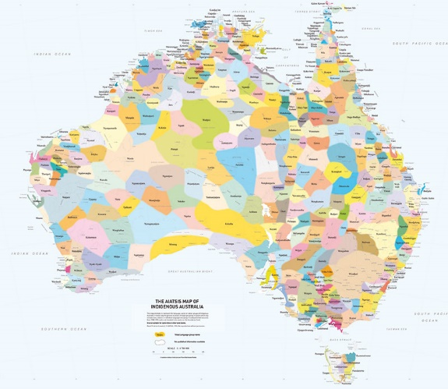
For over 60,000 years, our First Nations’ Peoples have occupied this continent as many different nations with diverse cultural relationships linking them to their own particular lands, waterways and seas.
Over 200 distinct languages, and countless dialects of them, were in use long before European colonisation began. While people in some areas continue to speak their own languages, many others are seeking to record and revive their own which were lost through the process of colonisation. Aboriginal and Torres Strait Islander peoples retain their connection to their nation dependant on and regardless of where they live today.
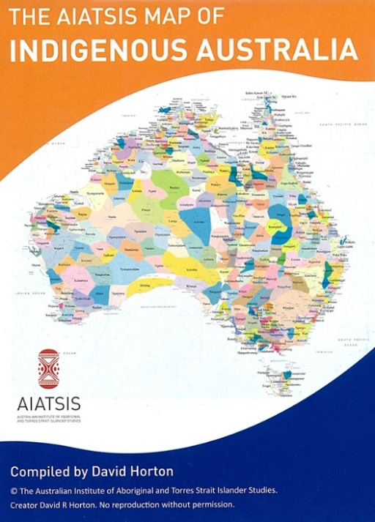
The highly popular AIATSIS map of Indigenous Australia is now available in a compact, portable A3 size. Available flat or folded (packaged in a cellophane bag), it is the perfect take-home product for tourists and anyone interested in the diversity of Australia’s first nations peoples. The handy desk size also makes it an ideal resource for individual student use https://www.google.com/search?q=indigenous+map+of+australia&safe=active&rlz=1C1CHZL_en&tbm=shop&source=lnms&sa=X&ved=0ahUKEwjp3v3e-rziAhWCfn0KHV02CjwQ_AUIDSgE&biw=1920&bih=937&dpr=1#spd=16677666823606559031.

“Where to buy”

Click on the “where to Buy” button for many options of where to buy Indigenous maps that will suit all budgets and purposes. One would look great hanging in your Corps and in our social program buildings too. What a great way to connect with our Aboriginal and Torres Strait Islander communities!

