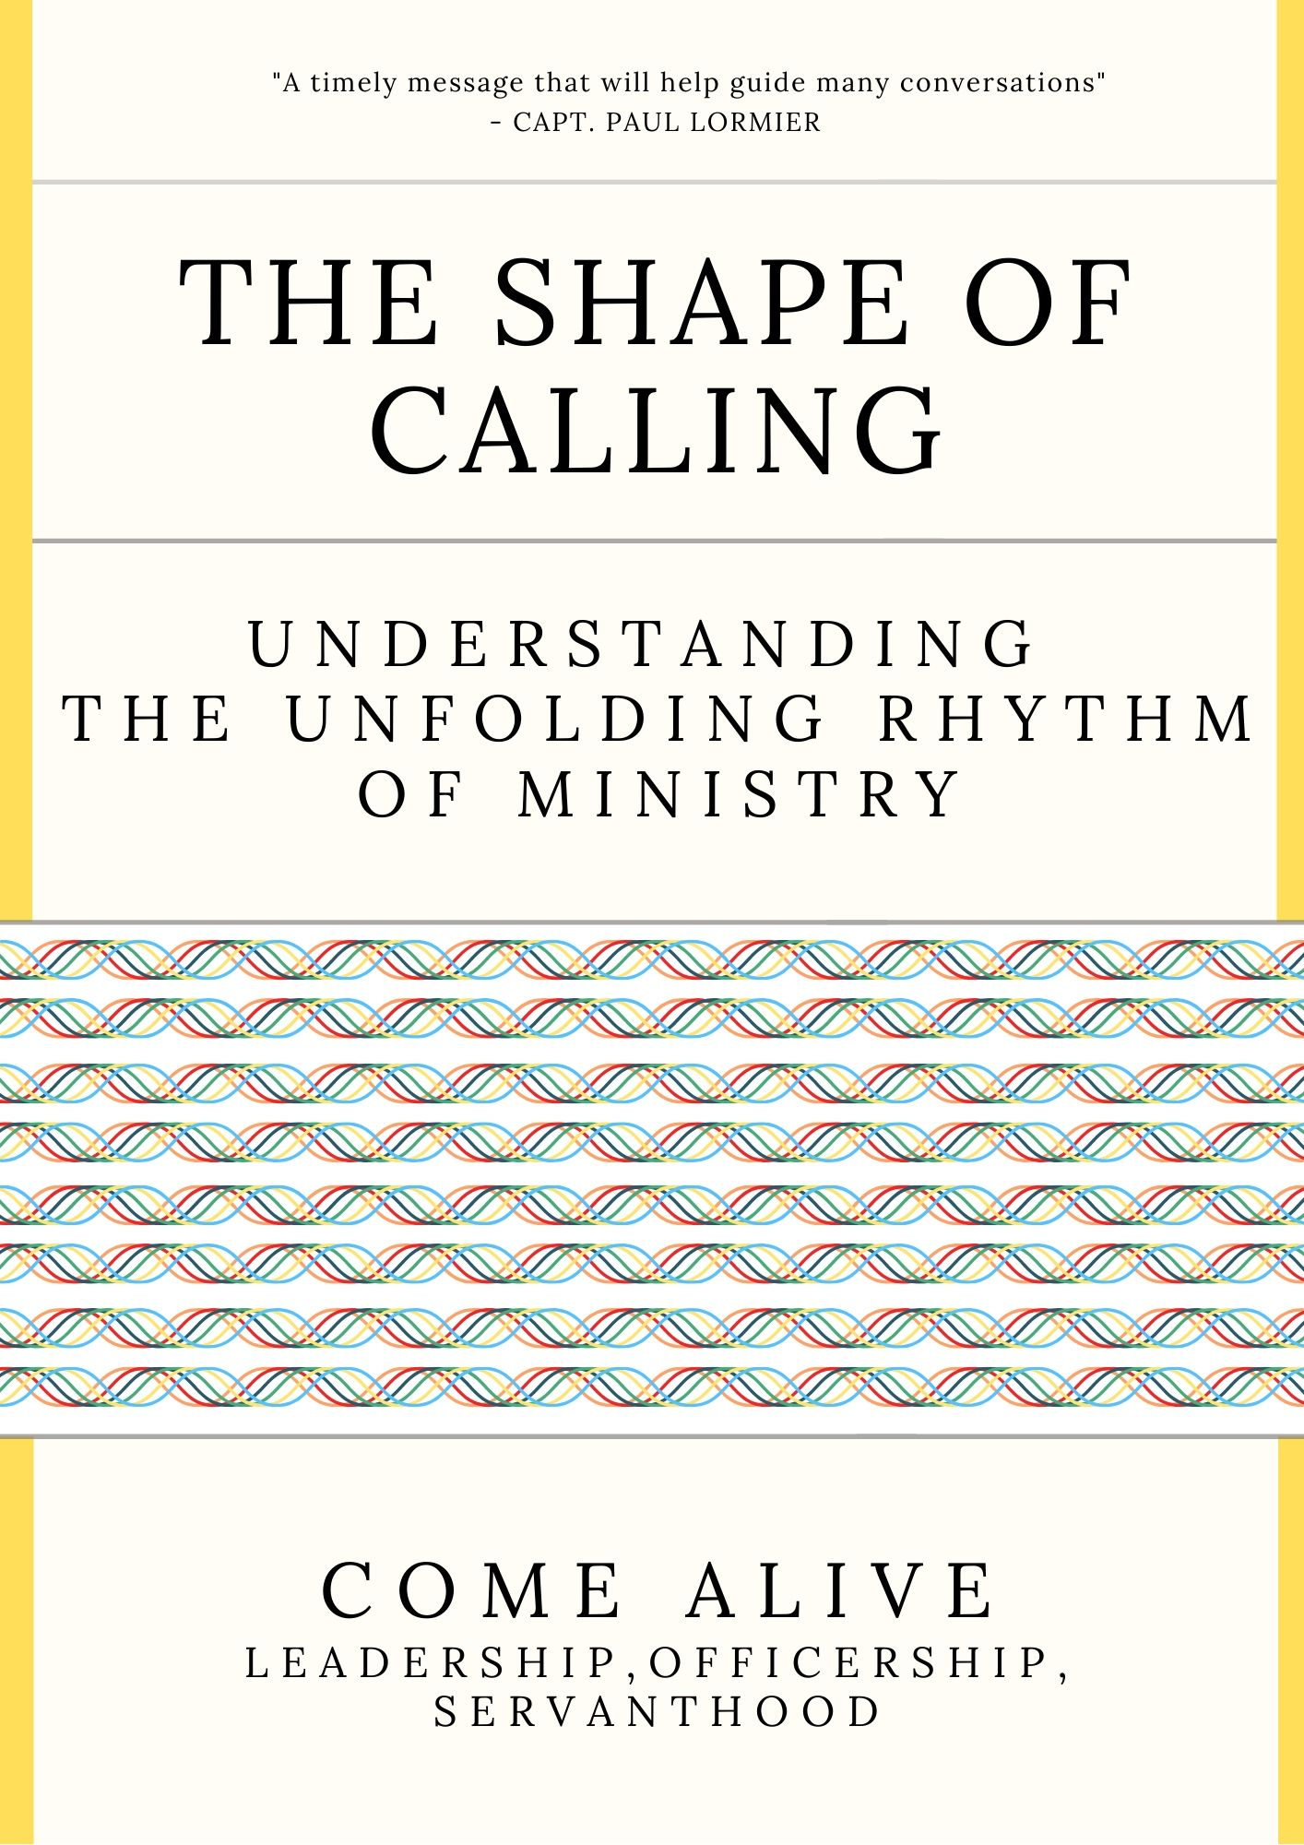
Message: The Shape of Calling, understanding the
unfolding rhythm of ministry
Sermon Outline

Overview
When we hear the word calling, it’s often used in reference to people going into ministry. This can be a helpful word for some but for others the idea of calling can be confusing. This message explores what is calling? Does everyone have a calling? How does calling occur? How do I respond to calling? Do all callings look the same?

1. A working definition
- Calling refers to the activity of God, whereby God asks, draws, or invites us to do something or to go somewhere.
- Calling is an invitation offered to us by God.
- The word calling means: to be spoken to, to be invited, or to be summoned by God.
- Calling can also refer to salvation or the invitation to grow Christ-like character.
Point 1. Calling is an invitation into a God initiated activity that requires our response.

2. Does everyone have a calling
2.a General call
- Scripture informs us that we all share in a general call – that is, our Christian witness.
- We are all called to love God, and to love our neighbours as we love ourselves.
- We are all called to share the gospel with others.
- Everyone has equal opportunity to be involved in ministry.
2.b Specific Call
- In the Old Testament, we see a number of specific callings.
- In the New Testament, we read about the calling to specific ministry roles.
Point 2.A&B. Calling is both General and Specific.

3. The Shape of Calling
- Specific calling rarely means a specific and predictable unfolding.
- Paul had a “specific calling, but not a specific outworking or predictable ministry.
- There is a flow and rhythm to calling; there is a flow and rhythm to ministry.
Point 3. It’s helpful to cultivate an attitude that remains open to how specific calling may unfold.

4. How calling occurs
- God doesn’t just communicate it one standard way.
- Calling is not an end in and of itself – it has a purpose.
- “People with strongest and healthiest sense of calling are not obsessed with their calling but with the caller” – John Ortberg.
Point 4. Calling can occur in a number of ways.

5. God’s what and God’s when
- God’s what is different from God’s when.
- It’s always the right time to share the love of Jesus with others.
- Sometimes a specific calling happens straight away, other times, it’s a long process.
- There is a need to discern the timing of God.
Point 5. God’s timing varies from person to person; remain open.

Message: The Shape of Calling, understanding the
unfolding rhythm of ministry
Sermon Transcript

Introduction | Today we’re going to talk about calling.  Normally in a church setting, when we hear the word calling, it’s often used in reference to people going into ministry. You may have heard comments like “God called me into ministry when I was a teenager” or “I’ve had a sense of calling for a long time now”. Or maybe someone’s asked you “What’s your calling?” or inquired of you “Have you ever thought about going into ministry?”  You may know someone who “is called” or heard friends say,  - “God’s called me to the marketplace, or to be a schoolteacher, or to start a business”,  - Or “I just have this strong sense of purpose when I do this specific thing”,  - Some people are motivated by a sense of responsibility from Scripture: “The Bible teaches this, so it simply an act of obedience”.  Calling is a bit of a loaded word - it can be a helpful word for some, but for others the idea of calling can be confusing and raise questions like:  - What is calling?  - Does everyone have a calling?  - How does calling occur?  - How do I respond to calling?  - Do all callings look the same?
Transition | So today, I’d like us to explore the topic of calling together and explore a few of these questions together.  Let’s begin with: what does the word calling mean?
1. A working definition | Calling refers to the activity of God, whereby God asks, draws, or invites us to do something or to go somewhere.  Calling is an invitation offered to us by God.  The word calling means: to be spoken to, to be invited, or to be summoned by God.  In essence, calling is an invitation offered to us by God.  In the Bible, calling can also refer to salvation or the invitation to grow Christ-like character:  - Acts 13:47 (NLT): For the Lord gave us this command when he said, ‘I have made you a light to the Gentiles, to bring salvation to the farthest corners of the earth.’”  - 1 Peter 2:19 (NIV): But you are a chosen people, a royal priesthood, a holy nation, God's special possession, that you may declare the praises of him who called you out of darkness into his wonderful light.  - Romans 8:28 (NIV): And we know that in all things God works for the good of those who love him, who have been called according to his purpose.  But no matter what definition we land on, calling – in each one of them – requires a response.  For today’s message, I’d like to use this definition of calling:  Calling is an invitation into a God initiated activity, role, or task – that requires our response.
Point 1. | Calling is an invitation into a God initiated activity, role, or task – that requires our response.
Transition | The next question that often surfaces is does everyone have a calling?
2.A  General Call | I believe the answer is yes.  But what we find in Scripture is that there are two types of calling: the General and the Specific.  Let’s start with the general call.  General call  Scripture informs us that we all share in a general call – that is, our Christian witness. We see this outlined by Jesus through the Great Commandment and the Great Commission.  - We are all called to love God, and to love our neighbours (others) as we love ourselves (Matt 22:37-9 The Great Commandment)  - We are all called to share the gospel with others (Matt 28:16-10 The Great Commission).  As a movement, we believe in what’s known as “the priesthood of all believers”, whereby everyone has equal access to God, and everyone has equal opportunity to be involved in ministry.  It’s not for the chosen few - we are all called to come alongside others and share the love of Jesus with the lost, the last, and the least.  And as a movement, The Salvation Army holds a pivotal ministry in the Body of Christ as those called to save souls and serve suffering humanity.  We’re not just about saying gospel words, and we’re not just about doing good deeds – we are a people of the AND – we do both. We minister to both the body AND the soul. And we all have a role to play in this, there is room for us all to minister.  Allow me to me encourage and remind us all here today to live out that general calling of the Kingdom of God. Jesus said we are called to be “Salt and Light” in this dark world (Matt 5:13-4).  To live out the gospel, to reveal the kingdom of God, to partner with God, to bring hope and restoration, to live, love, and fight alongside others – this is the calling to ministry we all share.
Transition | But we also need to acknowledge that God also calls people to specific tasks, roles, locations, and ministry functions.
2.B  Specific Call | Specific call  In the Old Testament, we see God calling:  - Abraham to start a nation  - Moses to deliver a nation  - Deborah to lead a nation  - David to rule a nation  - Esther to save a nation,  - And the prophets to speak to a nation.  These are all pretty big and unique callings. To bring it down to ground level for us here today, we also see God calling people to work with crafts (Exo 35:30-35, 36:1), to be musicians (1 Chron 15:16), to be in the marketplace (Dan 1:3-5), to be involved in social reform (Neh 13:1-31).  In the New Testament, we read in Ephesians 4:11-13 about the calling to specific ministry roles:  “And He gave some as apostles, prophets, evangelists, pastors and teachers, for the equipping of the saints for the work of service…”  Insert personal testimony of how you sensed, understand God’s calling for your life, or call to officership, or to a specific ministry/task.  - Perhaps you can identify with a specific calling?  - Perhaps God is calling you to Officership.  - Maybe God’s placed a dream in your heart for street mission?  - Or maybe God is leading you to fulltime study, or into business, or to become an educator, or be in the health industry.  - Perhaps there is a country or a global injustice that requires leadership and God keeps bringing it to your mind – inviting you in?  So, we all share in a general call to be a Christian witness, but God also calls people to specific tasks, roles, locations, and ministry functions.
Point 2. | Calling is both General and Specific
3. The Shape of calling | Now, what I would say about “specific” calling – is that while you may have a strong and clear sense of the call of God, what I have observed in Scripture and learned from experience, is that a specific calling rarely means a specific and predictable unfolding.  Let’s consider the apostle Paul. He had a specific calling to “be a light to the Gentiles” (Acts 13:47). He was called by Jesus to be a preacher of the good news to all the nations on the earth.  Fairly straight forward – open your mouth and speak. But what did this look like? How did this calling unfold? Not in one ministry expression, but in many:  - He first went and studied for three years (Gal 2:17-18), then  - He was a teacher in a local church (Acts 11:25-26), then  - He was a missionary, evangelist and church planter (Acts 13-20),  - Then he was a apologist, defending the faith in Rome (Acts 28),  - Then, he was a teacher for the Church (Epistles), and finally  - He was an author (Epistles in the New Testament).  Paul had a “specific calling, but not a specific outworking or predictable ministry.  It’s the same for us. There is a flow and rhythm to calling; there is a flow and rhythm to ministry.  It moves in and out, in and out, broad then narrow, broad then narrow, general to specific, general to specific – and the flow continues on throughout our life.  It might be helpful to imagine the “shape of calling” to be like a wave:  … we begin broad: The Great Commandment and Commission: Share the gospel with everyone: every tribe, every nation, every age, every gender, every background – everyone.  Then over time, we get an idea of how God has gifted us: our skills and our talents, and we work at developing our specific gifts.  Then we use them to help others, often in various ways and settings.  Then, as we grow in clarity of where God is leading us, we make specific choices to prepare us for the next season: we may go to school, or do a short course, or attend training College. We might join a ministry team, go on roster, serve in corps leadership, or go on a mission trip.  Then, over time, we may end up in another ministry setting, or appointment, or job, or team, and so on and so on…  Therefore, when it comes to a specific calling, one of the most helpful attitudes we can cultivate is being open to how it may unfold.  There is a flow and rhythm to calling.
Point 3. | It’s helpful to cultivate an attitude that remains open to how specific calling may unfold in our lives.
Transition | So we all have a place in ministry, there is a general and broad calling we all share in, and there are specific callings. But how does calling occur? Do we need a burning bush or something?
4. How calling occurs | Because calling is something God initiates, one of the other aspects we should touch on is how God communicates to us.  For us, there are many forms of communication we can use: email, text, facetime, letters, phone, in-person, online meetings, sign language, body language...  When it comes to calling, God doesn’t just communicate it one standard way. Calling may happen in a time of prayer, or when you’re reading the Bible, or through a spiritual experience. It may happen at the mercy seat or a sacred space. It can happen naturally through a conversation.  I’ve noticed that every leader’s story around their sense of calling occurs in a different way:  - Some had a clear sense that God was asking them to do something.  - Others had a dramatic experience.  - Some simply responded to what they read in the Bible – again, coming back to the Great Commandment and Great Commission.  - Others had a growing a sense of purpose and passion.  - For some, Officership is the best way to outwork their calling.  - Others came from a family whose parents we in ministry.  - Some had other leaders around them recognise a gift and calling to ministry and encouraged them to pursue it.  There are lots of ways calling can occur. What is common however, is that all of these leaders knew there was something simmering away on the inside, something deep down they felt they should be doing.  I think at this stage we need to remember that calling is not an end in and of itself – it has a purpose, and that purpose is about ministering to others. God has a world that needs to experience the love and person of Jesus.  I like what John Ortberg, a pastor in America writes, “People with strongest and healthiest sense of calling are not obsessed with their calling. They are preoccupied with the Caller.”
Point 4. | Calling can occur in a number of ways.
Transition | The final question I’d like to touch on is: when does God want us to step into our calling?
5.  God’s what and God’s when | Over the years, I’ve learned that God’s what is different from God’s when.  - When it comes to the general calling (the great commandment and the great commission), I think we can all agree it’s always the right time to share the love of Jesus with others.  - When it comes to a specific call, sometimes things happen straight away, other times, it’s a long process.  It’s important to discern the timing of God.  There is a gap we sometimes need to journey through and discern with the help of other leaders around us. It could be for our development. It could be to grow our capacity. We may need to learn new skills. Every season has a reason.  If you do sense God is calling you, I encourage you to speak to someone about it today.  If you feel a specific call to the mission of The Salvation Army, be it as a local leader, or as an Officer, or if you are interested in other options (e.g. serving as an Auxiliary Lieutenant) please come and speak to me.
Point 5. | God’s timing varies from person to person; remain open.
Illustration | Illustration…  A helpful illustration I once heard about discerning your calling is that it is much like flying a kite.  When you fly a kite, it’s all about catching the wind. We don’t create the wind, we can’t force the wind, we don’t decide which direction the wind blows, all we can do is catch and harness the wind.  When I was trying to catch the wind of God for my life, when I was trying to discern God’s call for me, the Spirit would always be blowing towards Officership/church orientated ministries. When I tried to steer my life – my kite as it were – away from church ministry and over towards secular employment, I always feel I am fighting against something. I believe it’s the wind of the Holy Spirit, blowing me towards the direction God intends for my life.  Now that’s just my experience – perhaps for you, you feel God’s wind pulling you towards business, or education, or to establish a career – that’s fantastic! We want to celebrate that with you.  Remember, calling is not about everyone ending up doing the same thing, it’s about living a submitted life to God, being fully available to where He will lead us next.
Close | I hope today’s message has helped clarify calling a little more for you, and you get a sense of the next steps you need to take.  And I hope you have felt stirred and challenged to engage in our general calling to the Christian life – we are all called to live out the Kingdom of God.  As we close, can I ask you, do you sense the wind of the Spirit blowing you in a certain direction? Are you trying to catch the wind or are you trying to fight against it?  For some us, perhaps this is a holy moment –a moment when the Holy Spirit is blowing over you afresh, drawing you towards a specific ministry. I encourage you to act on that. I invite you to have a conversation with me today, and we can explore where this may lead together.  Let’s pray.

Message: The Shape of Calling, understanding the
unfolding rhythm of ministry
Sermon Scriptures

*All Scriptures are taken from the NIV unless noted otherwise.

Acts 13:47 (NLT)
For the Lord gave us this command when he said, ‘I have made you a light to the Gentiles, to bring salvation to the farthest corners of the earth.’

1 Peter 2:19
But you are a chosen people, a royal priesthood, a holy nation, God's special possession, that you may declare the praises of him who called you out of darkness into his wonderful light.

Romans 8:28
And we know that in all things God works for the good of those who love him, who have been called according to his purpose.

Matt 22:37-9
Jesus replied: "'Love the Lord your God with all your heart and with all your soul and with all your mind…. And the second is like it: 'Love your neighbour as yourself.'

Matt 28:16-10
Then the eleven disciples went to Galilee, to the mountain where Jesus had told them to go. 17When they saw him, they worshiped him; but some doubted. 18Then Jesus came to them and said, “All authority in heaven and on earth has been given to me. 19Therefore go and make disciples of all nations, baptizing them in the name of the Father and of the Son and of the Holy Spirit, 20and teaching them to obey everything I have commanded you. And surely I am with you always, to the very end of the age.”

Matt 5:13-14
"You are the salt of the earth. But if the salt loses its saltiness, how can it be made salty again? It is no longer good for anything, except to be thrown out and trampled underfoot. "You are the light of the world. A town built on a hill cannot be hidden.

Exo 35:30-35, 36:1
30Then Moses said to the sons of Israel, “See, the LORD has called by name Bezalel the son of Uri, the son of Hur, of the tribe of Judah. 31“And He has filled him with the Spirit of God, in wisdom, in understanding and in knowledge and in all craftsmanship; 32to make designs for working in gold and in silver and in bronze, 33and in the cutting of stones for settings and in the carving of wood, so as to perform in every inventive work. 34“He also has put in his heart to teach, both he and Oholiab, the son of Ahisamach, of the tribe of Dan.

35“He has filled them with skill to perform every work of an engraver and of a designer and of an embroiderer, in blue and in purple and in scarlet material, and in fine linen, and of a weaver, as performers of every work and makers of designs. 1So Bezalel, Oholiab and every skilled person to whom the Lord has given skill and ability to know how to carry out all the work of constructing the sanctuary are to do the work just as the Lord has commanded.”
1 Chron 15:16
David told the leaders of the Levites to appoint their fellow Levites as musicians to make a joyful sound with musical instruments: lyres, harps and cymbals.

Dan 1:3-5
3Then the king ordered Ashpenaz, the chief of his officials, to bring in some of the sons of Israel, including some of the royal family and of the nobles, 4youths in whom was no defect, who were good-looking, showing intelligence in every branch of wisdom, endowed with understanding and discerning knowledge, and who had ability for serving in the king’s court; and he ordered him to teach them the literature and language of the Chaldeans. 5The king appointed for them a daily ration from the king’s choice food and from the wine which he drank, and appointed that they should be educated three years, at the end of which they were to enter the king’s personal service.

Ephesians 4:11-13
11And He gave some as apostles, and some as prophets, and some as evangelists, and some as pastors and teachers, 12for the equipping of the saints for the work of service, to the building up of the body of Christ; 13until we all attain to the unity of the faith, and of the knowledge of the Son of God, to a mature man, to the measure of the stature which belongs to the fullness of Christ.

Acts 13:47
For this is what the Lord has commanded us: "'I have made you a light for the Gentiles, that you may bring salvation to the ends of the earth.'"

Paul’s ministry journey: Gal 2:17-18, Acts 11:25-26, Acts 13-20, Acts 28, New Testament.

