Outlook eSignature for the Believe in Good brand campaign


Please follow these steps to add a new signature to your Outlook for the Believe in Good brand campaign with the correct format.
- Open the Outlook Application

- Click on new Email

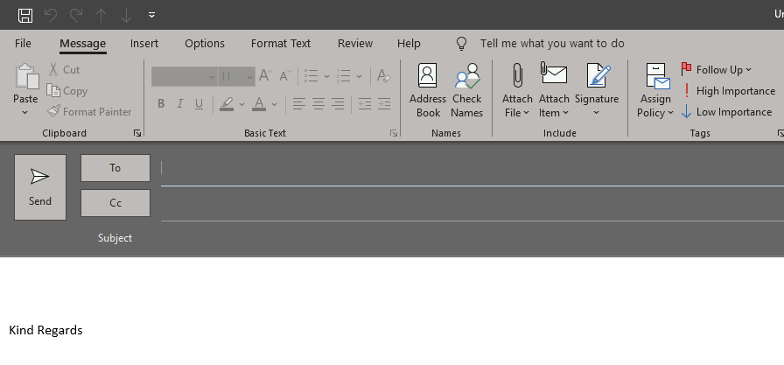

- Please click on ‘Signature’ tab

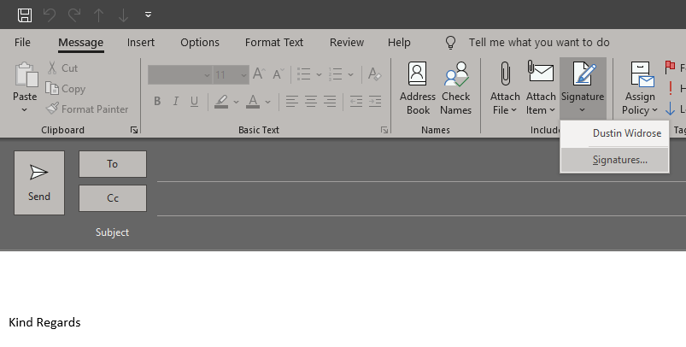

- Once you click on ‘Signatures’, the Signatures and Stationery box opens. Copy all the text up until your name (exclude the red shield logo), as highlighted below.

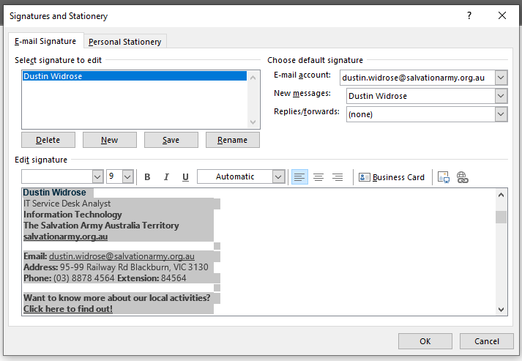

- Once you have copied the text, click on ‘New’

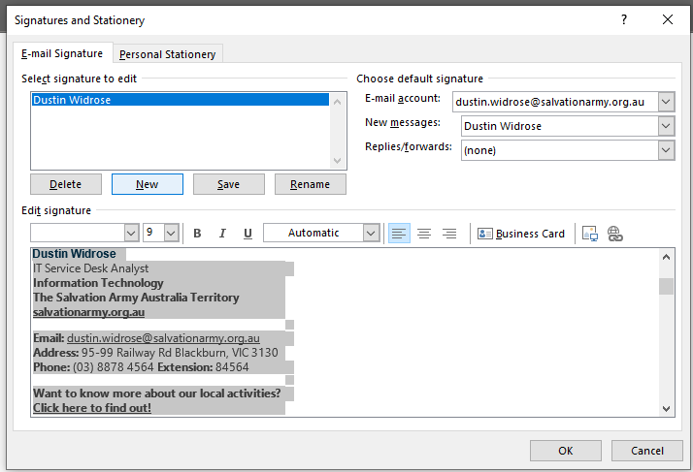

- Once you click on New, it will ask you to name the signature. Please name it as Believe in Good Signature.

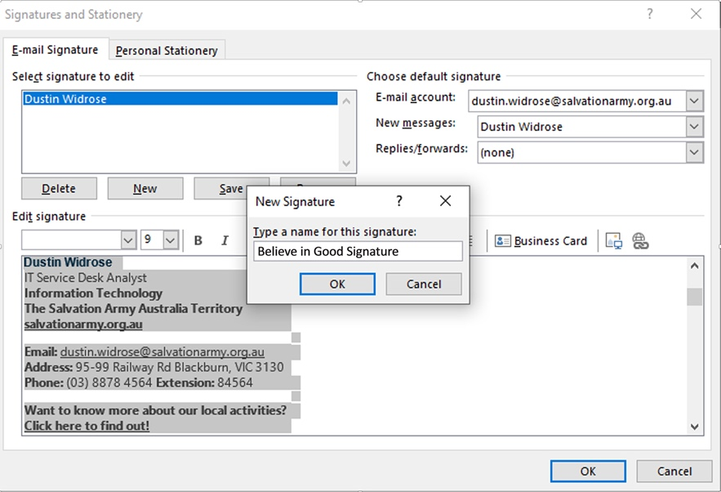

- Once you name it will show up as empty in the ‘Edit signature’ field. Please paste the text that you just copied into the text field.
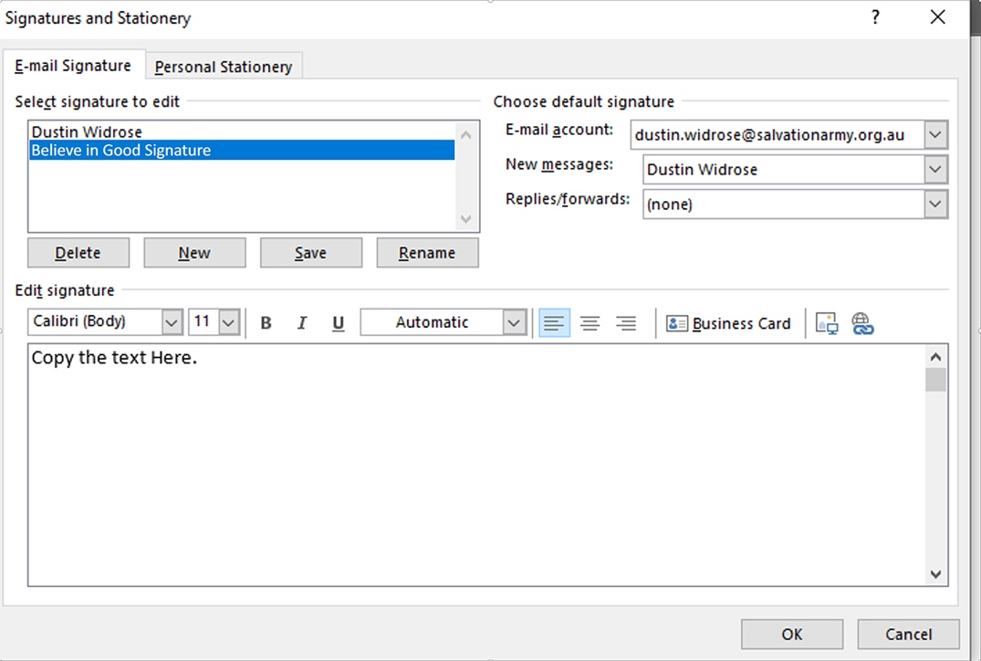

- Once that is copied please copy and paste the Believe in Good banner above the email line and below the website address line. Add some space below the website address and above the email address by adding a few return carriages. See large circle below.
Then click on the ‘Insert picture’ icon which is located to the right of ‘Business Card’. See small circle below.
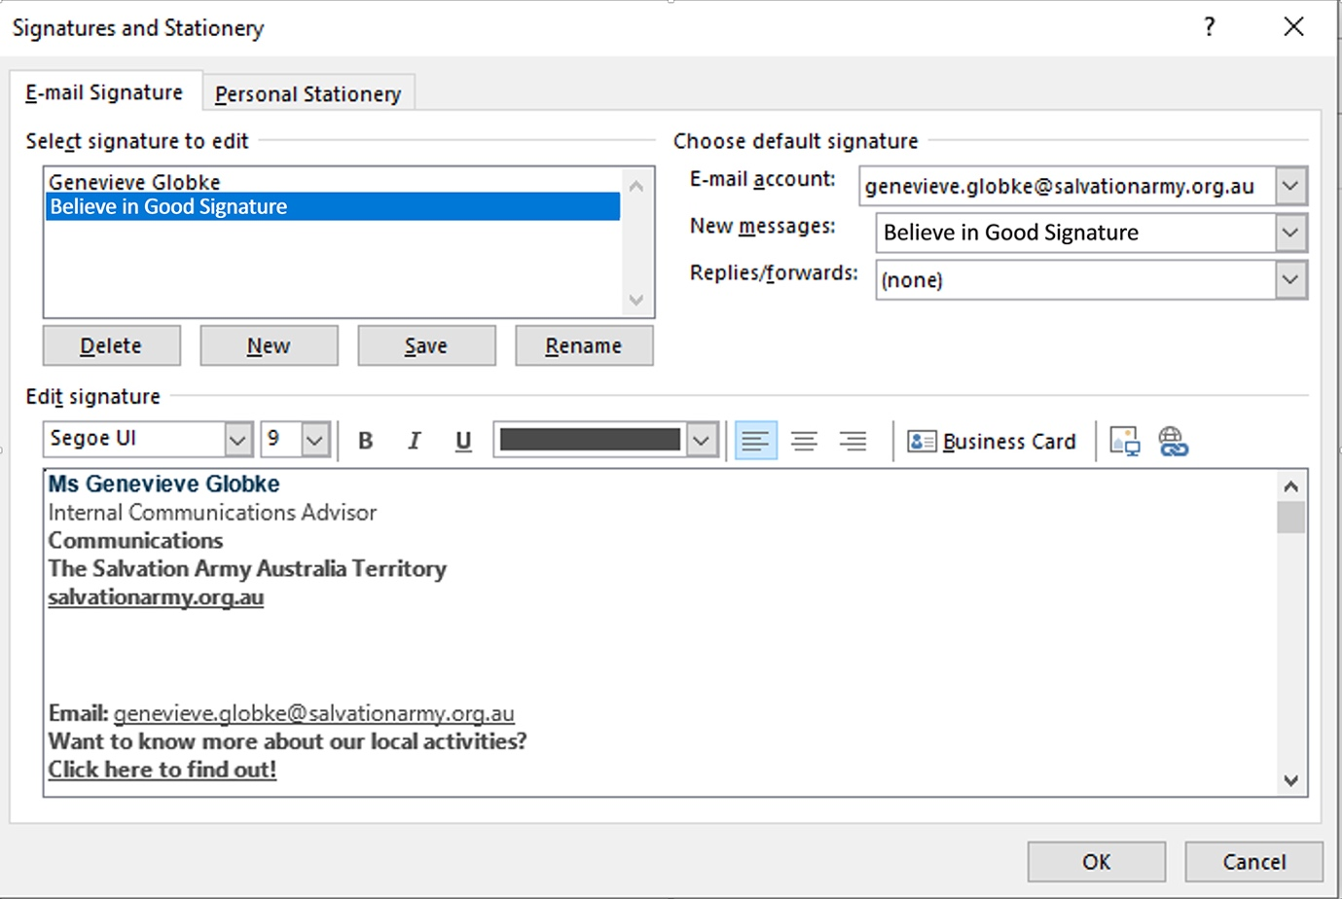

- Insert the Believe in Good eSignature banner (you need to save the file to your folders first). See below.

- To hyperlink the Believe in Good eSignature banner, click on the banner first to select it, then click on the ‘Link’ icon to the far right. See small circle below.
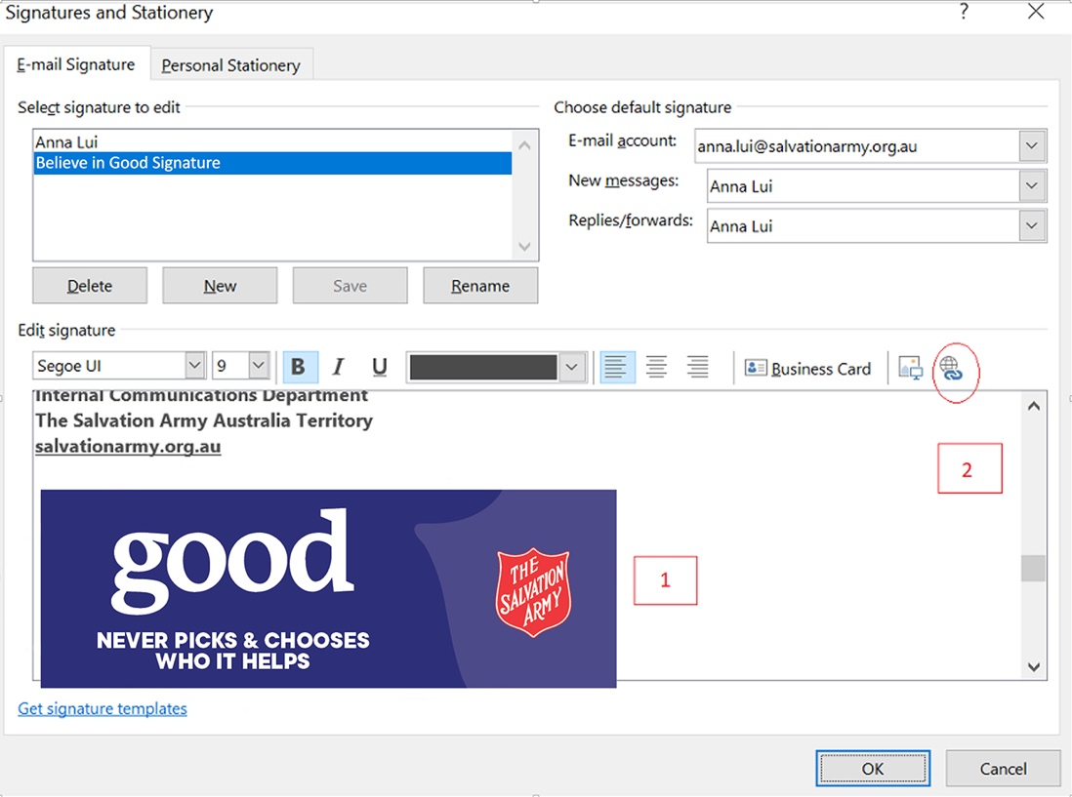
- The ‘Insert Hyperlink’ box appears. In the ‘Address’ field, paste in this URL then click ‘OK’.
https://www.salvationarmy.org.au/believeingood/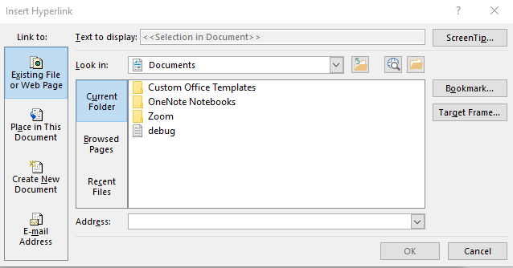

- Open a new email and go to the Signatures and Stationery box again. You will see that you now have two eSignatures to choose from (see circle on the left). To set the Believe in Good signature as default, go to the ‘New messages’ field, click the drop-down menu and choose ‘Believe in Good Signature’ (see circle on the right). Then click ‘OK’.

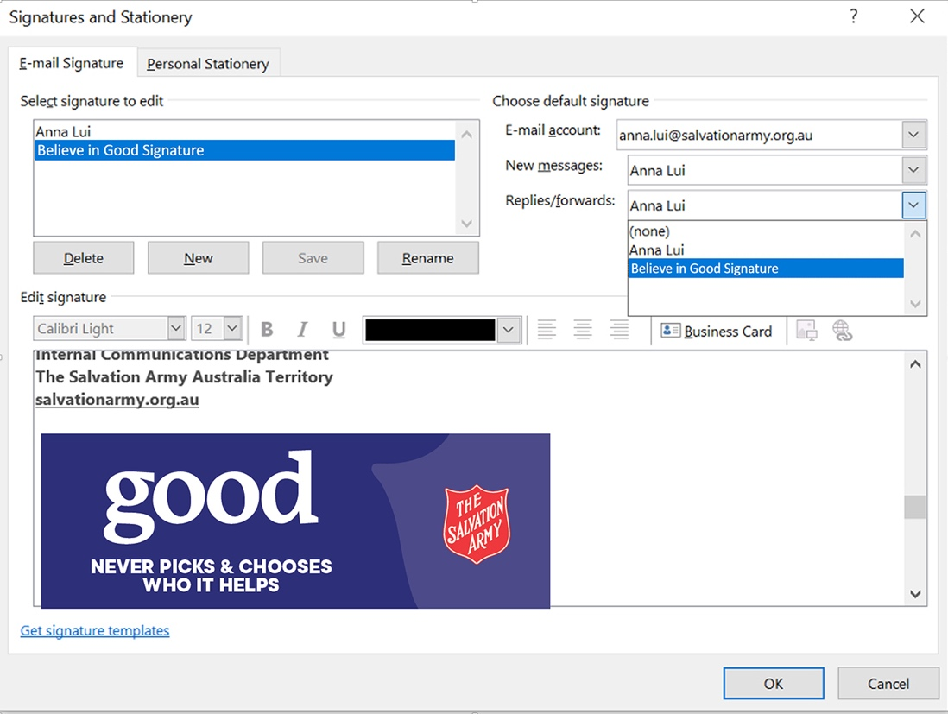

- Now, when you open a new email, the Believe in Good signature is now default.
Your new eSignature should look like this:


