Quest 850c: How to connect to a WIFI network (including a personal mobile hotspot)
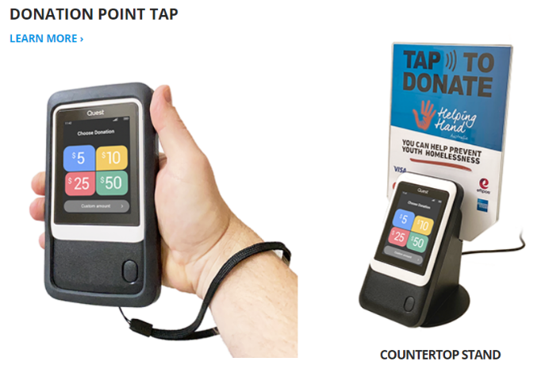
Quest devices connect to the Optus cellular network. So wherever there is Optus coverage, the machines should work fine. If there are issues connecting to the cellular network, then you can connect to a WIFI network - including a personal mobile hotspot. Therefore if TSA staff have work mobile phones on the Telstra network (with better coverage) they could connect their Quest Device to their phone hotspot.

Instructions to connect to a wifi network (including a hotspot) are below:
- To access the Communications menu, hold the ‘Power’ button down for 3 seconds.
- Tap [Settings] > [Communications].
- Enter the Merchant Passcode, then tap [Enter]. TSA passcode is: 604927
- Next tap the toggle to enable [WiFi].
- Ensure WiFi is active by tapping the [Use Wi-Fi] toggle. The toggle should slide to the right.
- Once active, all nearby WiFi networks will appear. Select the WiFi network you wish to connect to then enter your network password. Note that an unsecured WiFi network will not work.

