THE MANGER THRONE
To reflect this year’s ‘No ordinary child’ design, you might like to set up a manger with a crown on top it. This will provide a striking visual reminder that the baby we celebrate at Christmas was no ordinary child.
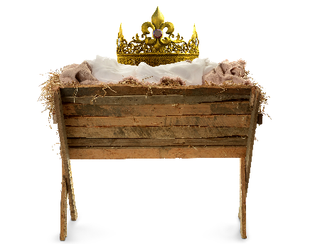
To do this:
- Build a manger from wood or cardboard (scroll down for instructions).
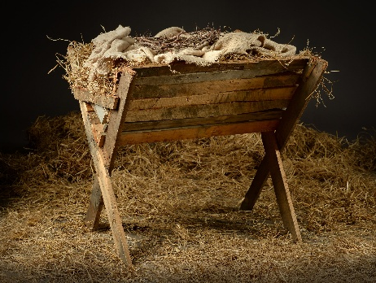
- Fill the manger with hay
- Find an antique-looking crown e.g. https://amzn.asia/d/7nH4Lne OR print crown on card
- Place crown on top of hay
- [Optional] Add hessian fabric around the base of the manger. E.g. https://www.spotlightstores.com/sewing-fabrics/furnishing-fabrics/general-purpose-fabrics/hessian/hessian-fabric/BP80185796
- [Optional] Suspend warm white twinkle lights above the manger to represent stars.
  - You can do this by using some microphone stands, or poles stuck in some buckets of sand either side of the manger and tape the lights to these poles to suspend them over the manger.
  - To make these poles look more appealing, hide them behind some foliage, fake trees, Christmas trees etc.

How to create a pallet wood manger
Tutorial: https://www.youtube.com/watch?v=xR_yx9UtbvU

How to create a cardboard manger

- Cut two of these shapes from A4 kraft paper. One shape per piece of paper.
- Fold A4 kraft paper in half, then starting from the fold, cut 2cm in from the edge, in a straight line to 1cm from the top.
- Slot the sides into that cut.
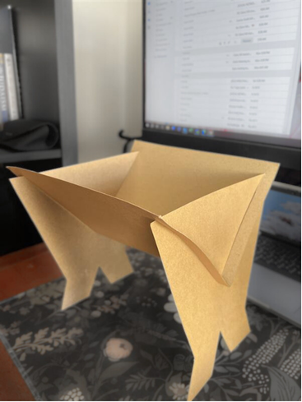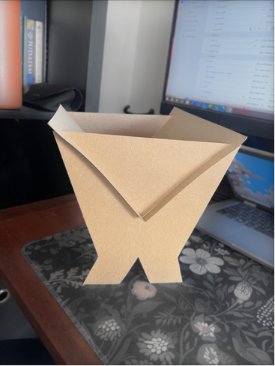
- Fill it with straw, paper straw etc.
- Decorate to own styling.

HANGING ORNAMENTS
Print out large copies of the themed graphics and create hanging ornaments for your entryway or meeting room. Themed graphics can be found via the Brand guide snapshot or silhouette cutouts can be downloaded here.
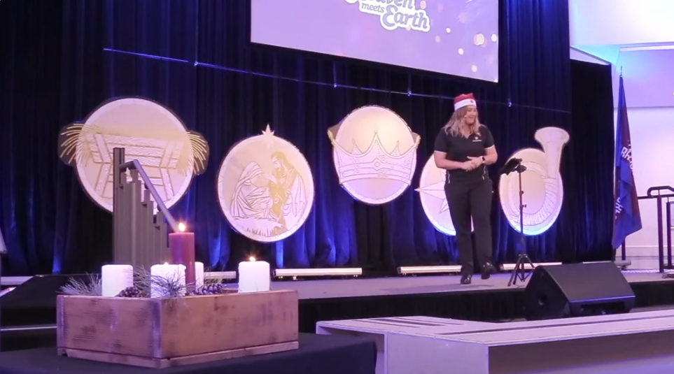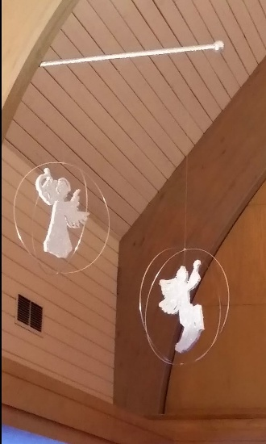
(Example above from Christmas 2024 theme)

GENERAL TIPS
- Decorate your area with warm Christmas lights – They will look classy and striking and help build excitement.
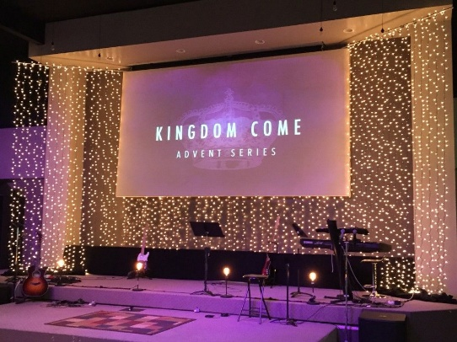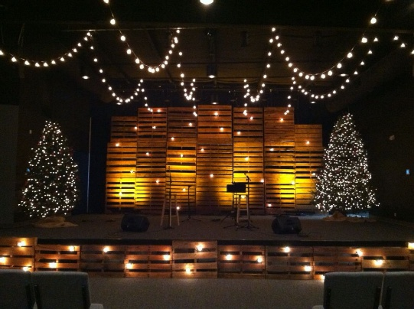

- Use natural materials - E.g., hessian or timber. This will help convey the earthiness of Jesus’ birth in the stable.
- Less is more – Take inspiration from this year’s graphic design and embrace a minimalist approach. A few, carefully chosen decorations will be more effective than a crowded or flashy display.


