Introduction
Father's Day, held on the first Sunday in September each year, is a day for us to celebrate fatherhood. It provides an opportunity for us as Christians to recognise the men who love us, who teach, support and encourage us. Some of these men are fathers and grandfathers, others take on a fathering role or are spiritual mentors. We honour them and give thanks to God for them.
We are also mindful that this day is difficult for many, for various reasons. We acknowledge their pain, and we support and encourage them on this day.
This document contains:
- Suggested Scripture verses
- Prayers
- Activity ideas
- Gift ideas

Scripture Verses
“³ Every time I think of you, I thank my God. ⁴ And whenever I mention you in my prayers, it makes me happy” (Philippians 1:3-4, CEV).

“The Lord is as kind to his followers as a father is to his children” (Psalm 103:13, ERV).

“²⁴ May the Lord bless you and protect you. ²⁵ May the Lord smile on you and be gracious to you. ²⁶ May the Lord show you his favor and give you his peace” (Numbers 6:24-26, NLT).

“The godly walk with integrity; blessed are their children who follow them” (Proverbs 20:7, NLT).

“¹³ Be on guard. Stand firm in the faith. Be courageous. Be strong. ¹⁴ And do everything with love” (1 Corinthians 16:13-14, NLT).

“And you saw how the Lord your God cared for you all along the way as you traveled through the wilderness, just as a father cares for his child” (Deuteronomy 1:31a, NLT).

“His preaching will turn the hearts of fathers to their children, and the hearts of children to their fathers” (Malachi 4:6a, NLT).

“¹⁴ May the Lord richly bless both you and your children. ¹⁵ May you be blessed by the Lord, who made heaven and earth” (Psalm 115:14-15, NLT).

Prayers
A short prayer:
Heavenly Father,
We thank you for being the ultimate example of a good father. You are loving, patient, and faithful. Thank you for your guidance, protection and care.
We thank you for this special day where we set aside time to honour our earthly fathers and father figures – those who have championed us through life. We celebrate them today.
We pray that you would raise up godly men to stand with and support the next generation. Please give all fathers and father-figures renewed strength and the kind of peace that only comes from you. Please bless each one of them today.
In Jesus’ name, Amen.

A multi-generational prayer:
Invite people of different ages to participate in reading one line each of this prayer. You might like to use this as an example and ask people to create and contribute their own sentence.
Optional: write the first word of each line of the ‘men’s’ prayers on a separate piece of cardboard. Arrange for people to bring each corresponding sign as the men pray, then stand beside them/hold their hand and hold up the sign.
Women: Father God, today we celebrate and thank you for fathers and men who…
Children of all ages:
- Are generous with their time and pay attention
- Make space to listen to us
- Share our adventures and our wonder
- Model how to love people
- Say sorry when they need to and forgive others
- Teach us and give us good advice
- Let us learn from our mistakes and help us to set things right again
- Show us how to live like Jesus
Women: Father God, we acknowledge that being a father is not always easy. So, we pray for fathers and the men who nurture and guide us. We pray for…
Men:
- Patience as we serve our families
- Strength as we gently lead
- Wisdom as we listen well and give careful guidance
- Courage to face the challenges that arise
- Integrity to speak the truth and act faithfully
- Humility to admit when we are wrong and ask for forgiveness
- Compassion to love others unconditionally
- Joy as we celebrate the adventure of investing in the lives of our children
All: Amen

A poem-prayer: Thank You, God, for our Dads

We pray for our dads, grandads and dads-in-law,
adoptive dads, single dads, stepdads and more
For pastors and mentors, our teachers and friends,
our role models, heroes, whose impact won’t end

We pray God would bless them and help them to know
just when they sit down, they’ll be back on the go
They’ll drive us to footy, guitar and ballet,
They’ll wait ‘round for hours, just watching us play

Some fathers are happy, and some are in pain
Some dads are in Heaven – we’ll see them again
Some fathers are tough and some have had it rough
We pray they experience God’s perfect love

We celebrate now all the dads we hold close
We give them our love, and some eggs on some toast
We give dad great presents, like undies and socks,
We bake him a cake and we tell him he rocks!

Oh thank you, our Father, for giving us dads
Lord, thank you for being the best one we’ve had
We pray we’ll stay close to you, never to part
We know that you love us with all of your heart

Amen.

Activity ideas
Idea 1: Faith stories
Ask up to five children to share for up to one minute each about how their father/father-figure helps them grow to be more like Jesus.
They might like to touch on:
- Spiritual habit/routines
- Praying together
- Opportunities to serve together
- Encouragement to treat others with kindness
Father’s Day is an opportunity to celebrate the unique bond we can share with our fathers and father figures. To help us do that, we have some special volunteers who are going to tell us about how their dads help them follow Jesus.
Let’s give them a big round of applause as they come up!

Idea 2: Whiteboard challenge
You will need:
- Six small whiteboards and markers
- Six chairs – set the chairs on slight angles to each other to make it harder for pairs to see what is being written by their partner.
Each pair should consist of a father-figure and one of their children (young or old). All participants will need to be able to write their answers on their whiteboard.
Father’s Day is an opportunity to celebrate the unique bond we can share with our fathers and father figures. To help us do that, we have some special volunteers who are going to join us for a little competition.
Let’s give them a big round of applause as they come up!
Ask the pairs to sit next to each other and give each one a marker and whiteboard. Explain that you will be asking some questions and everyone needs to write their answers on the boards. The goal is to get the same answer as their partner.
Ask one question at a time, then invite the participants to reveal their answer. If a pair has matching responses, they score a point – the wording doesn’t need to be exact.
- What is [adult’s] favourite colour?
- What is [child’s] favourite hobby?
- What is one way that you are alike?
- Which of you runs faster?
- What is something [child] has taught [adult]?
- What is something [adult] often says?

Finish by asking the child to share one thing they love about [adult] and one way they help them follow Jesus.

Gift Ideas
Meat rub
Find a small jar like the Ikea Spice Jar and fill with meat rub ingredients. Add one of the stickers provided.
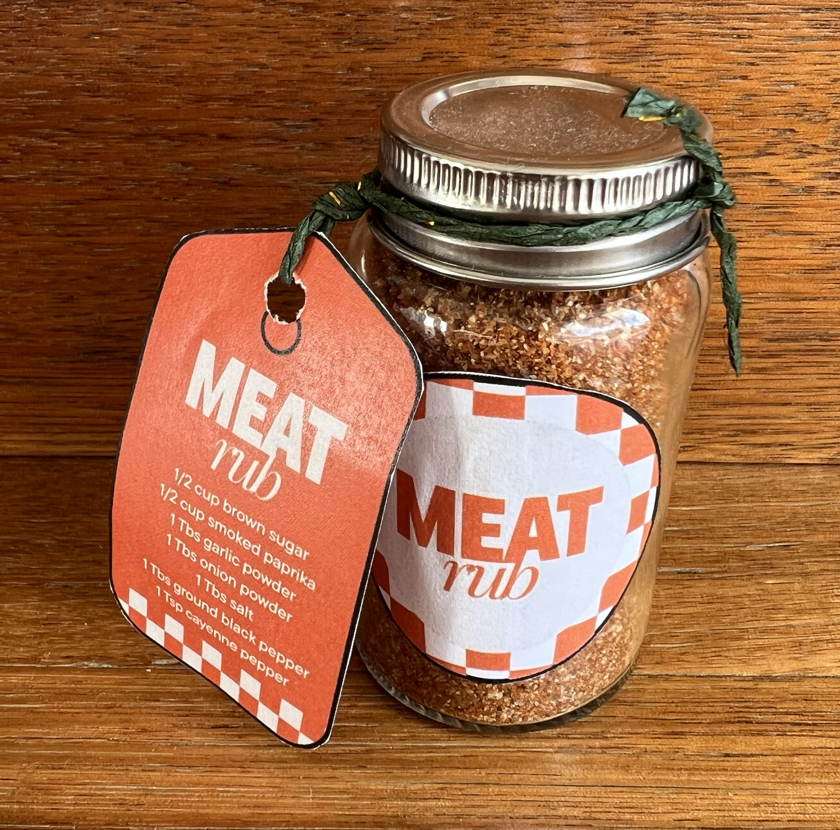
Ingredients (makes 4 jars)
- 1/2 cup brown sugar
- 1/2 cup smoked paprika
- 1 tablespoon garlic powder
- 1 tablespoon onion powder
- 1 tablespoon salt
- 1 tablespoon ground black pepper
- 1 teaspoon cayenne pepper (optional)
Mexican spice
Find a small jar like this one and fill with meat rub ingredients. Add one of the stickers provided.
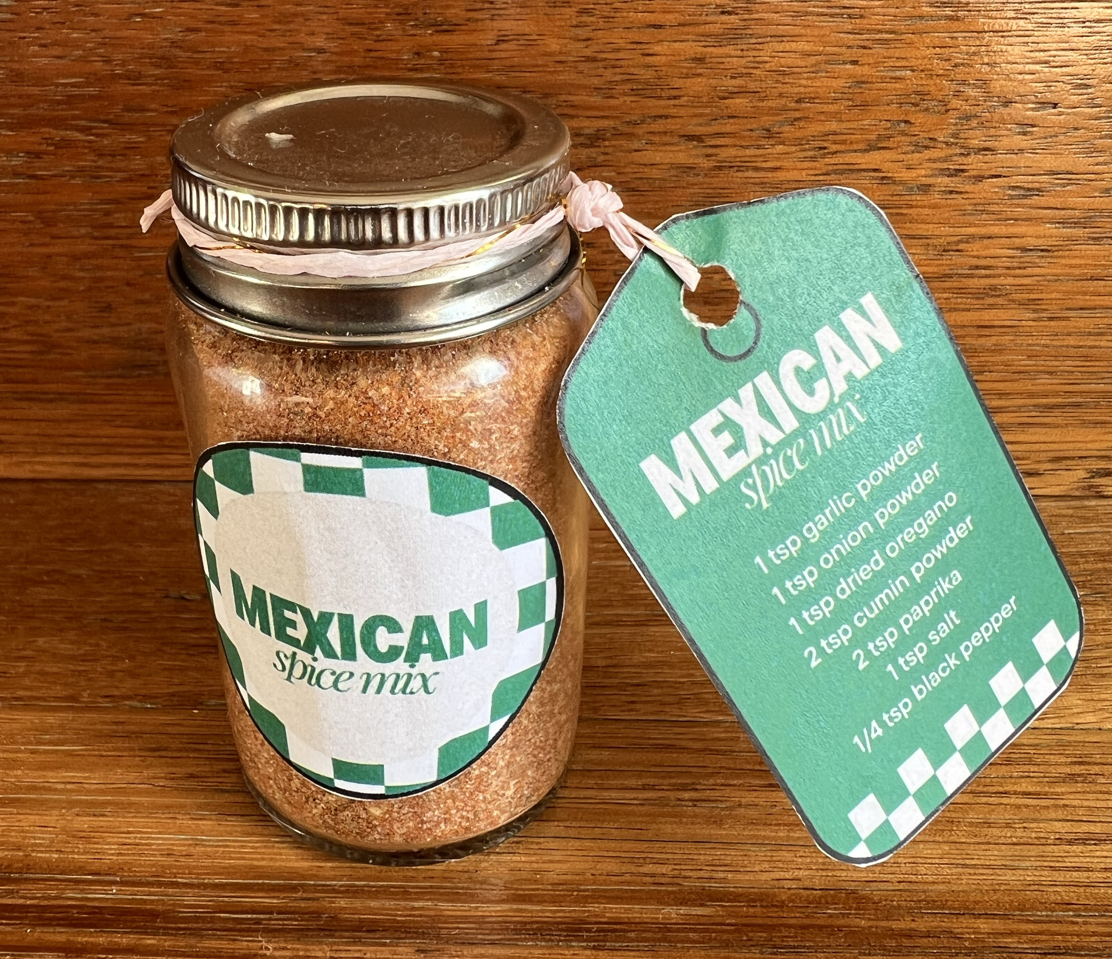
Ingredients (makes one jar)
- 2 tsp garlic powder
- 2 tsp onion powder
- 2 tsp dried oregano
- 4 tsp cumin powder
- 4 tsp paprika
- 1 tsp salt
- 1/2 tsp black pepper

Shaving oil
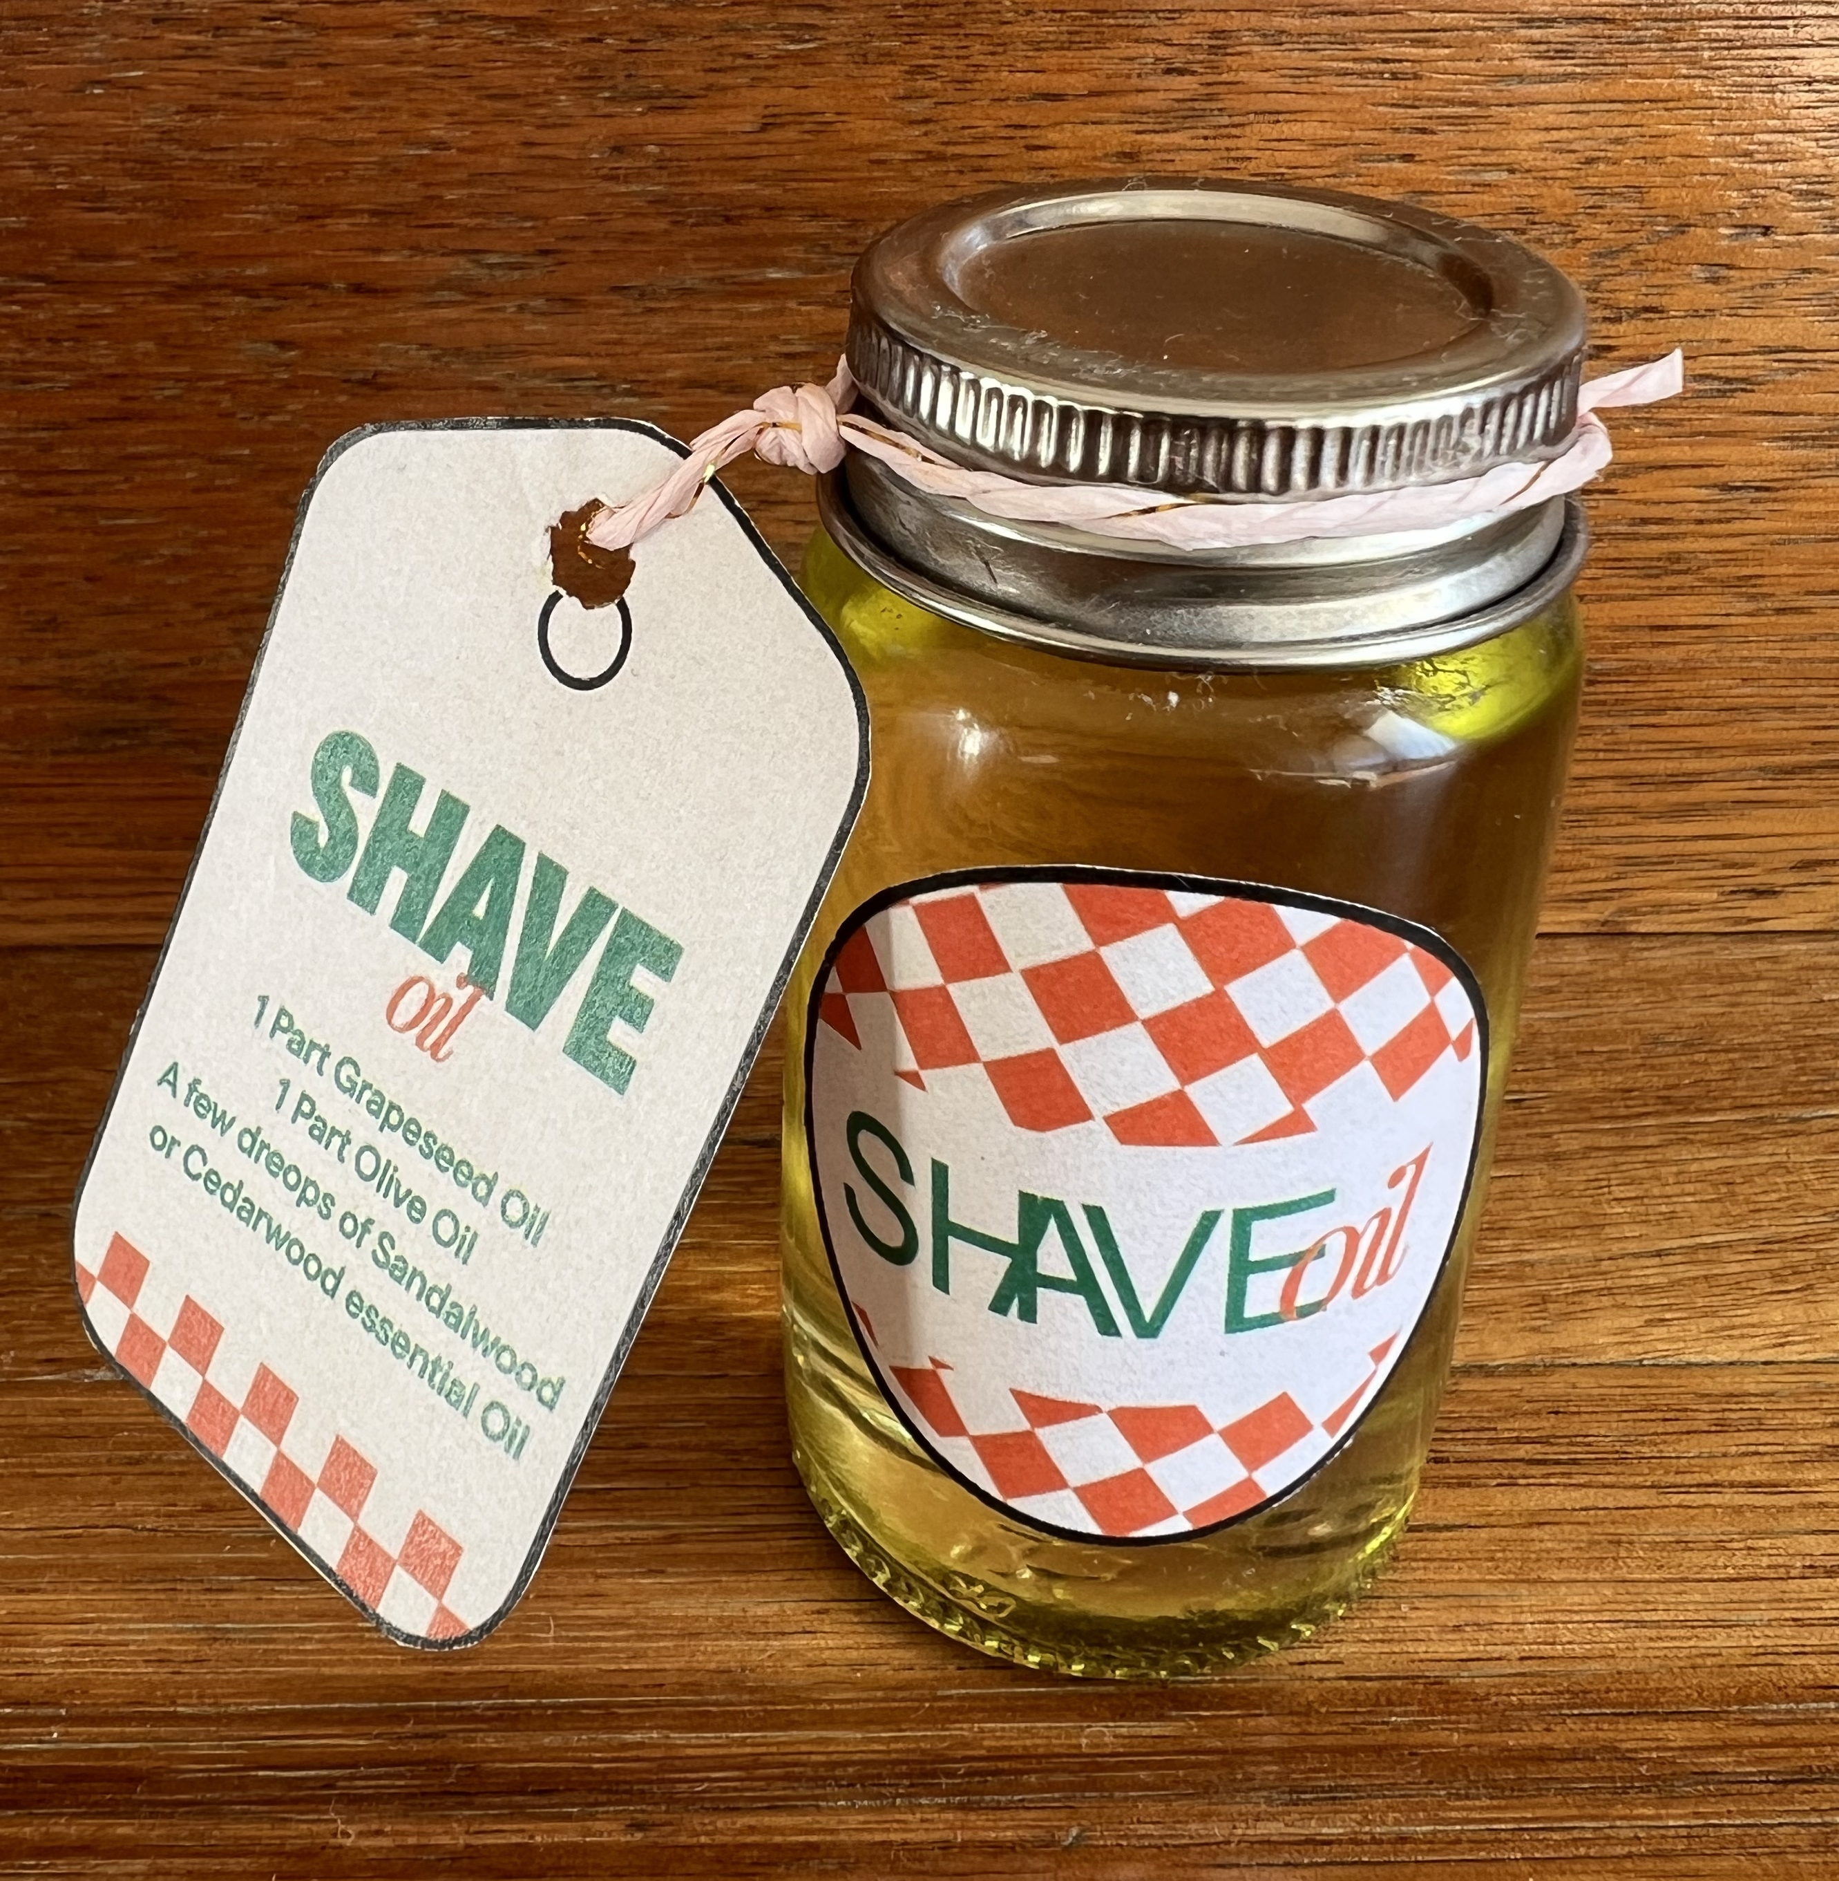
Place the following ingredients into a small spice jar:
- 1 part grapeseed oil
- 1 part olive oil
- A few drops of an essential oil of choice: sandalwood or cedarwood

Chocolate cup
Fill a takeaway coffee cup with chocolates. Add a gift tag from the templates provided.


