This is to certify that
________________________________________

has been appointed
Patrol/Team Leader

____________________________ Patrol/Team
_________________________________________ Corps
_________________________________________ Date

_______________________________ Section Leader

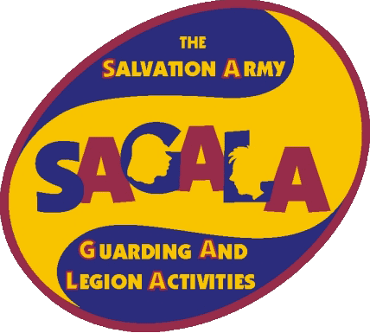


You are trusted to:
- be responsible for the
appearance, behaviour and
discipline of your Patrol/Team.
- set a good example in all your words and actions.
- help your Patrol/Team to do its best and work together as a team.





