SAGALA Badge Coupon
Please scan or save as PDF, then email the form to – trade.sydney@salvationarmy.org.au
Please ensure you have typed in the email subject line: SAGALA

Please ensure you have -
- Complete and email through a SEPARATE Coupon for –
a) Badge b) Enrolment c) Star Award d) Church Parade/Event e) Service Stars

- Please specify “Own Choice” next to the Award Level if that applies for the particular member

- If the coupon is for a Star Award, please ensure the Church Parade/Event date has been completed as this needs to be recorded on the database in order for the Star Awards to be achieved.
- If ordering Patrol stripes, tick Badge box and next to name of badge put “Patrol Stripes” and under Award Level put 1 or 2

For your information-
- The details will be entered into the database and badges will be sent as soon as possible by regular post – this may take around one week. Express Post may be requested, but you will be billed for this premium service.

- Corps will receive a bill four times per year, for the badges.

COUPON:  Retain a copy for your own records |  | ☐ BADGE ☐ ENROLMENT ☐ STAR AWARD  ☐ CHURCH PARADE/EVENT ☐ SERVICE STARS
CORPS
LEADER’S NAME |  |  |  |  |  |  | DATE
MOONBEAMS (M) & EXPLORERS (E) |  |  |  |  |  | Total number of badges required
Name of Badge
Member’s Name |  |  | Award Level/ Star Award/ Service Stars | Section:  M or E | Member’s Name |  |  |  | Award Level/ Star Award/ Service Stars | Section:  M or E
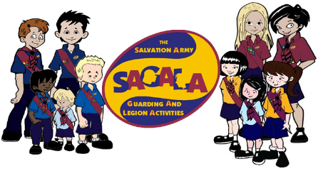

SUNBEAMS (S) & ADVENTURERS (A) |  |  |  |  | Total number of badges required
Name of Badge |  |  |  |  |  | Category
Member’s Name |  | Section:S or A | Award Level/ Star Award/ Service Stars | Member’s Name |  |  |  | Section:S or A | Award Level/ Star Award/ Service Stars
GUARDS (G) & RANGERS (R) |  |  |  |  | Total number of badges required
Name of Badge |  |  |  |  |  | Category
Member’s Name |  | Section:G or R | Award Level/ Star Award/ Service Stars | Member’s Name |  |  |  | Section:G or R | Award Level/ Star Award/ Service Stars

